RIVER OF WISDOM: A PERSONAL RETREAT ON THE ROSARY PART TWO
FR. JOHN BARTUNEK, RCspirituality.com

LEARNING FROM MARY’S EXAMPLE
The power of Mary’s motherly presence made a difference in Christ’s life, and it can make a difference in our lives too. But devotion to the Blessed Virgin Mary has a second and a third form as well. The second form is her example.

Mary was the first Christian, the first and most perfect follower of Jesus Christ. Being free from sin and filled to overflowing with God’s grace, she shows forth the new life that Christianity is all about. Children learn how to be human from the example of
their mother — they learn through her example and instruction how to talk, how to behave, how to relate to other people, how to tie their shoes. Just so, in the wisdom of God’s divine plan for the Church, we who are God’s children by the adoption of grace learn how to be
Christians through the shining example of our mother in the order of grace.

St. Louis de Montfort, author of the spiritual classic True Devotion to Mary, takes this concept of Mary as the shining example of Christian living even one step further. He describes how the role of Mary in our lives is to shape Christ within us, to mold us to his image, just as, through the Holy Spirit, she molded Christ himself in her womb.

A LESSON FROM DANTE
Dante’s Divine Comedy is one of the most influential works of literature in the history of western civilization. It is an epic poem written in the late Middle Ages and divided into three parts: Hell, Purgatory, and Heaven.

In the section on Purgatory, Dante shows a mountain with seven levels. On each level are souls who are being purified from leftover sinful tendencies in preparation for their entrance into heaven. There are seven levels because there are seven capital sins, seven basic sins from which the dozens of other sins are derived. On each level of the mountain, the souls are receiving a purifying punishment that counteracts whichever capital
sin dominated their life on earth. It’s a fascinating and enlightening study of selfishness and its destructive power in our lives.

But he finishes up his description of each level by showing how the virtue most needed by the souls who are stuck there — that virtue that would correct their dominant capital sin — was exemplified in the Gospels by the Blessed Virgin Mary.

The souls suffering from sloth, for instance, have to learn from Mary’s example of loving zeal when she “went into the hill country with haste” to help her pregnant elderly cousin Elizabeth (Luke 1:39). These brief glimpses of Mary’s shining virtue are among the
great treasures of the Gospels.

In them, the Holy Spirit has preserved just enough scenes and comments on the behavior and actions of the Blessed Virgin Mary to paint a portrait of what a mature Christian looks like. When we contemplate
those Gospel scenes, and Mary’s example of obeying, loving, and following Jesus Christ, we are brought to know, love, and follow him more closely ourselves

A CHILD’S INSTINCT
Absorbing our Christian life through contemplating the example of our spiritual mother comes spontaneously to those who are in tune with the Holy Spirit. I once received an email from a friend who illustrated this principle beautifully. She had just been to the
funeral of a relative who had died because of suicide. The family was quite close, and the suicide had been a terrible shock to everyone. It was a true tragedy, and
she was reeling in the midst of it.

As she was sharing her experience in her email, and asking me to support the family with my prayers, the following line just flowed spontaneously from her fingers as she typed:
I can’t imagine Mary’s Agony at the loss of Jesus...
There is so much to learn and I only feel I am skimming
the surface. I pray to do his will.

In the midst of her own confusion, pain, and sorrow, her heart just naturally reached out to Mary in order to find comfort, meaning, and strength. She was learning from her spiritual mother how to suffer as a Christian.

THE PIETÁ
And we all need to learn from her. Another friend I know was telling me how much she had suffered when she experienced a miscarriage. And through it all, the Holy Spirit kept bringing to mind the image of Michelangelo’s famous sculpture of the Pieta.

This sculpture shows Mary holding the dead body of her crucified son in her lap. And yet, in spite of the horror and the tragedy of that loss, in the sculpture Mary’s face shows great peace, the peace that sprang from her great faith, and her hands manifest a kind of supernatural strength and trust in God’s wisdom.

That image allowed this woman to find light and grace in the suffering of her own miscarriage. Mary’s example of Christian living, of Christian virtue, of Christian thinking and behaving and deciding — this is the second fundamental form of Marian devotion.

INVOKING MARY’S INTERCESSION
The third fundamental form of Marian devotion consists in invoking her intercession. God is not greedy or selfish. Instead of reserving every piece of salvation history to his own direct action, he has chosen to involve us in his work of redemption. His grace acts within us, but also mysteriously leaves room for us to act, to decide, to be creative, to help each other, and to intercede for each other through prayer. I can ask you to pray for me; and I know God will hear your prayer. You can do the same with me. It gives God glory when his children work together like that, just as parents are filled with healthy pride when their children support each other and are involved in each other’s needs, projects, and celebrations.

Of all the saintly intercessors that we have in heaven — of all the Christian brothers and sisters who have gone before us to the Father’s house — none are as loving
or as powerful in their supernatural aid as Mary, the Mother of Our Lord.

THE ICON OF CANA
She showed this even when she was here on earth. The first miracle that Jesus performed happened at the wedding in Cana. Ancient wedding celebrations would last for days, or maybe even an entire week, and all the relatives and neighbors would celebrate the marriage with great joy and fanfare. Wine was an important part of that celebration. And at this wedding in Cana, the wine had run out before the celebration was done — a terribly shameful situation for the young couple to find themselves in.

Well, Mary, the attentive mother, discovered the problem before anyone else. And she went right over to her son, Jesus, and told him about it. And although he hadn’t been planning on doing any miracles that day (he actually told her, “my hour has not yet come”), he granted her petition. He miraculously transformed about 120 gallons of water into excellent wine. This is the pattern for countless other miracles that have occurred through the intercession of the Blessed Virgin Mary ever since.

THE QUEEN MOTHER
It makes a lot of sense that Mary would have a particular influence in the court of the King, because the King is truly her son. This was God’s plan for his people since
the beginning. Just as the human race fell through the sin of Adam and Eve, a man and a woman, so it is fitting for the redemption to involve a new Adam — Christ —
and also a new Eve, the Blessed Virgin Mary.

We see this role of Mary foreshadowed quite explicitly in the Old Testament. There, among God’s chosen, the most influential role of the Queen of Israel was not exercised by the kings’ wives, but by their mothers. Here is how the First Book of Kings describes
the way that King Solomon received his Queen Mother, Bathsheba, when she came to make a request of him:
Then Bathsheba went to King Solomon to speak to him
for Adonijah, and the king stood up to meet her and
paid her homage. Then he sat down upon his throne,
and a throne was provided for the king’s mother, who
sat at his right. She said, “There is one small favor I
would ask of you. Do not refuse me.” The king said to
her, “Ask it, my mother, for I will not refuse you...” – 1 Kings 2:19-20

This scene shows the role that the Queen Mother had in ancient Israel, a role that imperfectly foreshadowed the more perfect relationship that would become
established for all eternity between Jesus and Mary and the rest of God’s family.

Mary’s special role as heavenly intercessor has been central to the lived faith of the Church since its earliest years. In fact, one of the earliest non-scriptural prayers used by Christians was a hymn to the Blessed Virgin Mary. It was already being used in the Coptic liturgy in
the third century. Its Latin name is Sub Tuum Presiduum, and it goes like this:
We turn to you for protection, O Holy Mother of God;
listen to our prayers and help us in our needs; deliver us
from every evil, O Glorious and Blessed Virgin. Amen.

Five hundred years later, in the chaos and strife of the early Middle Ages, we find another eloquent example of Christians turning to the intercession of the Blessed Virgin Mary. At the time, the most important city of Christendom was under siege by Moslem invaders. To
repel the attack, the Christians didn’t use military might or diplomacy, but prayer, including the invocation of Mary’s intercession.

Every day, the Patriarch of the city, St. Germanus, led a procession around the tops of the walls that protected the city — a procession in full sight of the besiegers. The procession included prayers, hymns, incense, and gave a prominent place to a venerated image of Mary, Mother of God. The siege, and the daily procession, lasted an entire year, and in the end, the city was miraculously liberated. Pope Benedict XVI made reference to this miraculous, historical event in one of his catechetical instructions.
In fact, Constantinople was liberated from the
besiegement. The adversaries decided to permanently
let go of the idea of establishing their capital in the city
that was the symbol of the Christian empire, and the
appreciation for divine help was extremely great among
the people. – Wednesday Catechesis, 29 April 2009

In that same catechesis, the Pope quoted a spiritual reflection from St. Germanus that highlights the Blessed Virgin’s role as motherly intercessor for all Christians. It goes like this:
May it ever happen, Most Holy Mother of God, that
Heaven and earth, honoured by your presence, and you,
with your departure, leave men and women without
your protection? No. It is impossible to think of such
things... You did not at all abandon those to whom you
had guaranteed salvation... You, O Mother, are close
to all and protect all, and although our eyes are unable
to see you, we know, O Most Holy One, that you dwell
among all of us and make yourself present in the most
varied ways...

This is our spiritual mother, the Queen Mother of Christ’s everlasting Kingdom — someone we can call on for help, today, tomorrow, and always.

CONCLUSION: AN ARTIST’S INSIGHT
A famous artistic image of the Blessed Virgin Mary brilliantly expresses these two forms of Marian devotion — her example and her intercession. It was painted by Michelangelo towards the end of his long life, as part of his Last Judgment, the monumental fresco adorning the Sistine Chapel inside the Vatican — the chapel where the cardinals gather to elect popes. In this painting, angels are blowing the trumpets to announce the end of history and the moment of the Last Judgment. In the lower left-hand corner, the dead are rising, and being brought to Jesus — who occupies the center of the painting — for judgment. Those who died in grace are then sent up into heaven, while those who
died in rebellion against God are dragged down to hell by voracious demons.
Clinging to the side of Christ, watching the people who come to be judged, is a feminine figure clothed in red and blue. It’s a symbolic figure of the Church, but it is also a depiction of the Blessed Virgin Mary. If you look closely, you see that all the other people who come
into Christ’s presence for judgment are either naked or barely clothed.

This symbolizes the very nature of judgment — nothing can be hidden from the eyes of God; all of our sins and flaws are open to his loving gaze. Only Mary is fully clothed. And this artistic symbolism is a reflection of the theological truth that, through God’s grace and her cooperation with that grace, she was free from sin.

She has no moral or spiritual flaws that she would want to hide from the Lord. In other words, she is our great model and shining example of Christian living. And if you look closely again, you can see another artistic choice that expresses a deep theological truth.
In the fresco, Mary is clinging to the Lord in such a way as to be able to whisper into his ear. As she looks at the people who come in front of the throne of judgment, we can imagine her interceding on their behalf, talking to her son about each of them with maternal concern, imploring his mercy.

This is our spiritual mother, our mother in the order of grace. She shows us the way into Christ’s heart with her example of every Christian virtue, and she
to follow that way and live those virtues in the often confusing and difficult challenges of life in a fallen world.

Take some time now to prayerfully reflect on these two aspects of Marian devotion — her inspiring and transforming example, and her powerful motherly. Ask God what he wants you to take away from this meditation, and don’t be afraid to listen to his answer. The following questions and Bible passages may your meditation.

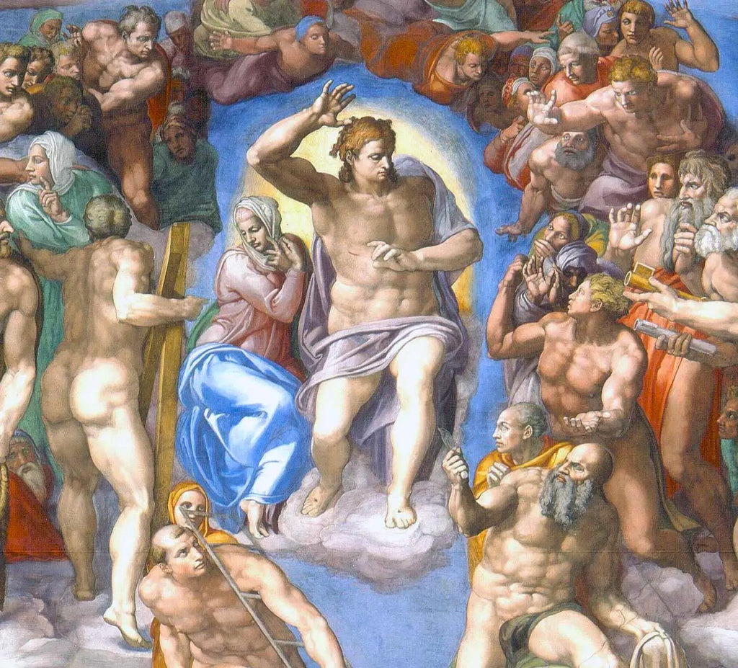

REFLECTION QUESTIONS
1.Reflect on my own experience of Marian devotion up to this point in my spiritual life. What has been most influential for me up to now, her presence, her example, or her intercession?

2.How consciously and frequently do I contemplate Mary’s example of following and accompanying Jesus? How consciously and frequently should I contemplate it?

3.How firmly do I believe in the power of Mary’s intercession? What personal experiences have affected my faith in that intercession?

BIBLICAL PASSAGES TO HELP YOUR MEDITATION
During those days Mary set out and traveled to the hill
country in haste to a town of Judah, where she entered
the house of Zechariah and greeted Elizabeth. When
Elizabeth heard Mary’s greeting, the infant leaped in her
womb, and Elizabeth, filled with the holy Spirit, cried out
in a loud voice and said, “Most blessed are you among
women, and blessed is the fruit of your womb. And how
does this happen to me, that the mother of my Lord
should come to me? For at the moment the sound of
your greeting reached my ears, the infant in my womb
leaped for joy. Blessed are you who believed that what
was spoken to you by the Lord would be fulfilled.” – Luke 1:39-45

On the third day there was a wedding in Cana in Galilee,
and the mother of Jesus was there. Jesus and his disciples
were also invited to the wedding. When the wine ran
short, the mother of Jesus said to him, “They have no
wine.” And Jesus said to her, “Woman, how does your
concern affect me? My hour has not yet come.” His
mother said to the servers, “Do whatever he tells you.” – John 2:1-5

When the angels went away from them to heaven,
the shepherds said to one another, “Let us go, then, to
Bethlehem to see this thing that has taken place, which
the Lord has made known to us.” So they went in
haste and found Mary and Joseph, and the infant lying
in the manger. When they saw this, they made known
the message that had been told them about this child.
All who heard it were amazed by what had been told
them by the shepherds. And Mary kept all these things,
reflecting on them in her heart. – Luke 2:15-19

