MOTHER TERESA: A SAINT WHO CONQUERED DARKNESS
Kerry Walters St. Anthony Messenger

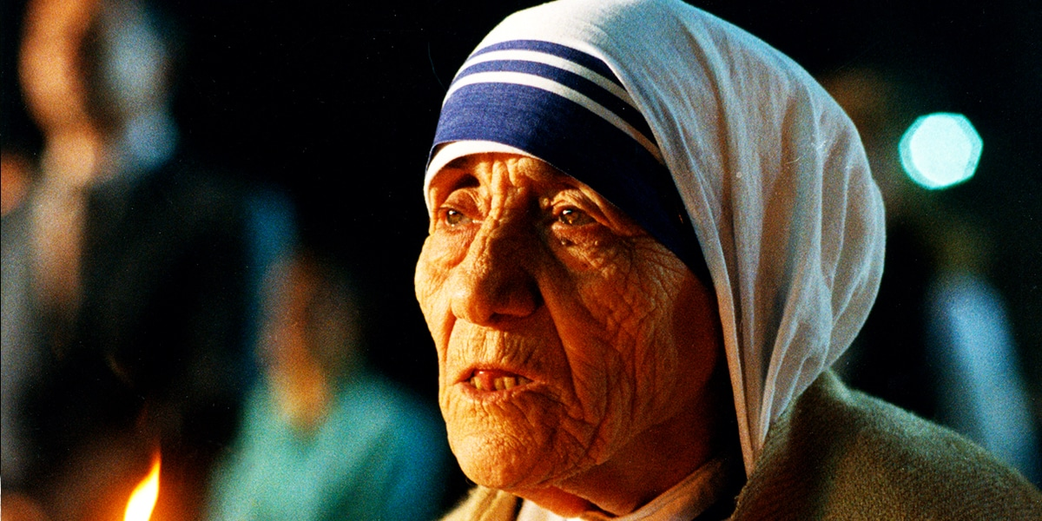

This beloved saint wrestled with her own dark night of the soul.

One of Mother Teresa’s deepest fears after she founded the Missionaries of Charity was that she or one of her sisters and brothers would do or say something to cause scandal or detract from the Order’s mission. In all likelihood this explains, at least in part, her reluctance to speak publicly of the interior locutions she had experienced for seven or eight months after the call within a call came on the train to Darjeeling.

Yet Teresa did cause scandal, although only after she’d been dead for a decade, and then only for a short time. In 2007, Come Be My Light, a book that collected many of her most personal and private correspondence, was published. It immediately caused sorrow and confusion in her admirers and a glee that bordered on what the Germans call schadenfreude, taking pleasure in another’s misfortune, in her detractors.

Her letters revealed that, except for one short period, Teresa had been afflicted with a deep sense of God’s absence for the last half-century of her life. Such was her unflagging dedication to the work she’d undertaken for God that most of the world was completely unsuspecting of her spiritual darkness.

On hearing the news, many Christians were confused. What did Teresa’s long stay in the spiritual wilderness mean? Was she a victim of depression? Had she lost faith in God? What gave her the inner strength to carry on even when she anguished over what she felt to be God’s abandonment of her?
Even Teresa’s closest companions in the Missionaries of Charity were bewildered. Never had she made any reference to the darkness except for an oblique reference that would’ve meant nothing to anyone but her confessors with whom she shared what she was going through. Four years before she died, she warned her sisters that “the Devil” is continuously on the prowl in order to “make you feel it is impossible that Jesus really loves you, is really cleaving to you. This is a danger for all of us.” None of them could have guessed that the remark was autobiographical.

For their part, Teresa’s detractors pointed to the revelations in Come Be My Light as evidence that Teresa was a faux-saint whose public displays of piety were hypocritical. Longtime critic Christopher Hitchens declared that the letters revealed Teresa to be a “confused old lady” who had “ceased to believe,” and whose service to others was nothing more than “part of an effort to still the misery within.” He also argued that the Catholic Church’s interpretation of Teresa’s time in the desert as a dark night of the soul was a perverse piece of marketing that sought to spin despair as faith.

A Soul in Anguish
There’s no sense in denying that Mother Teresa’s sojourn in the wilderness is disconcerting. If God can seem absent to a saint like her, what chance do the rest of us have to connect with God? It’s also quite probably true, given the nature of her work among the poorest of the poor, that at times Teresa felt psychologically depressed or burnt out. What normal person wouldn’t? But to conclude that the darkness was the result of depression, much less loss of faith, is to overlook its spiritual significance.

Psychological depression is me-centered; the depressive’s gaze is always directed inward. Teresa’s, on the other hand, was directed outward, to the God whose absence she so keenly felt. Depression renders a sufferer listless; Mother Teresa was always on the go, doing the work to which she felt God had called her. Moreover, dark periods don’t necessarily suggest a loss of faith. Instead, they are recognized in the Christian tradition as periods of great spiritual development.

Many Christian saints have recounted their own experiences of darkness in their relationships with God, but it was the sixteenth-century St. John of the Cross who wrote what’s still considered to be the best analysis of them. Not surprisingly, Mother Teresa knew his writings and once remarked that even though John’s words made her “hunger for God,” they also expressed what for her was “the terrible feeling of being ‘unwanted’ by Him.”

For John of the Cross, the noche oscura or “dark night of the soul” is a forlorn feeling of being abandoned by God. “Both the sense and the spirit,” he writes, “as though under an immense and dark load, undergo such agony and pain that the soul would consider death a relief.” The soul suffers most from the conviction that “God has rejected it, and with abhorrence cast it into darkness.”
But what feels like abandonment is far from it. The painful sense of being rejected by God is actually a purgation of the senses and spirit that prepares the way for an “inflow of God into the soul.” There is no set time limit for a dark night of the soul, although most do not last as long as Mother Teresa’s did. Nor does the dark night mean that the sufferer has ceased to believe in God, although intense doubts can arise.

In one of her letters, Mother Teresa writes, “In my soul I feel just that terrible pain of loss—of God not wanting me—of God not being God—of God not really existing.” But the occasional dreadful thought that God may be a fiction wasn’t her primary torment.

Even if Teresa had never read John of the Cross’s description of the noche oscura she would’ve had some idea of it from her namesake, St. Thérèse de Lisieux, the Little Flower, who likewise suffered from a sense of abandonment toward the end of her short life. Thérèse wrote that “God hides, is wrapped in darkness,” and she accounted for this by arguing that the love of Christ is so overwhelming that its fullness has to be withheld from mortals, a withdrawal that naturally causes suffering.

Mother Teresa’s suffering when God hid from her was intense. From first to last, her private correspondence to her confessors attests to that. Just a few passages, representative of the whole, convey something of the loneliness into which her sense of God’s absence drove her.

The longing for God is terribly painful and yet the darkness is becoming greater. What contradiction there is in my soul.
—The pain within is so great…Please ask Our Lady to be my Mother in this darkness.
The place of God in my soul is blank—There is no God in me.
In the darkness…Lord, my God, who am I that You should forsake me?…
The one You have thrown away as unwanted—unloved.
I call, I cling,
I want—and there is no One to answer—no One on
Whom I can cling; no, No One. Alone. The darkness is so dark—and I am alone.
Before I used to get such help & consolation from spiritual direction—from the time the work has started—nothing.

“The work” Teresa mentions in the last quotation refers, of course, to the ministry to which she was called on that providential train trip to Darjeeling. What especially bewildered and saddened her was that the darkness had descended in 1949, right when she believed she was doing precisely the work God had created her to do. Her loss of the presence of God coincided with the granting of the long-sought permission to found the order that became the Missionaries of Charity. Surely the Vatican’s approval was a sign from God that he loved her and wanted her to succeed. But it was just at that point that she felt the door slam shut. God disappeared.

There was to be but one time the door opened in her many years of darkness. Pius XII was the pontiff who gave permission to found her Order. When he died in October 1958, Archbishop Périer celebrated a requiem Mass in the Calcutta cathedral. Teresa attended, and on that same day received a respite from her forlornness. As she wrote Périer, “I prayed to [Pius] for a proof that God is pleased with the Society. There & then disappeared that long darkness, that pain of loss—of loneliness—of that strange suffering of ten years. Today my soul is filled with love.”

But in just a short time, God “thought it better for me to be in the tunnel—so He is gone again.” Teresa would endure the tunnel for the next four decades.

Yes to God
As the years of darkness came and went, Mother Teresa slowly began to see them as something different from the dark night of the soul described by John of the Cross and experienced by Thérèse de Lisieux. It was, she concluded, an essential part of her vocation as a Missionary of Charity.

Even as a teenager back in Skobje, Teresa had longed to serve the poor. When she became a missionary nun, she spent her Sundays roaming the slums around the Loreto compound bringing relief to the poor. When she received the call within a call, she dedicated the rest of her life to giving the poor, the sick, the lonely, and the dying the love that the world had denied them. Moreover, she voluntarily took on their poverty as her own.

Teresa dedicated her life to this work because she believed that Christ demanded it of her. As she so often said, when she succored the poor and the sick, she ministered to Christ in his distressing disguise, the Christ who thirsted. So it was perhaps inevitable, given that she shared in the suffering of the people she served, that Teresa would eventually discern her own inner poverty as a share in the suffering of Christ himself. She remembered the oath she’d made back in 1942 never to deny God anything asked of her, and she realized that loyalty to the oath meant embracing God’s withdrawal.

“We must know exactly when we say yes to God what is in that yes. Yes means ‘I surrender,’ totally, fully, without any counting the cost.” It meant accepting whatever God gave, and giving whatever God chose to take away. And for Teresa, it meant accepting the burden of Christ’s Passion.

When she was allowed that insight into the nature of her darkness, she recognized it as an inevitable aspect of the call within a call, and would go so far as to say that she actually loved the darkness because it was “a part, a very, very small part of Jesus’ darkness & pain on earth.”

Lost and Found
Teresa’s final years were ones in which poor health and physical suffering became her daily burden. Just a few months before her death, suffering from heart failure and pneumonia, she lay in a hospital bed, unable to speak because of the bronchial tube that had been inserted to help her breathe. She tried to communicate with her caretakers by writing on slips of paper, but was too weak to do so. Finally, mustering all her strength, she was able to scrawl, “I want Jesus.” Mass was celebrated in her hospital room and she was able to take a small amount of the consecrated wine.

Those who were with her at the time believed that her request for Jesus meant that she desired the Eucharist, and that’s surely a part of what she meant to communicate.
But given her decades of living without a sense of Christ’s presence, it’s not too much to conclude that she also meant she wanted the darkness of God’s withdrawal to end. She’d spent over fifty years reliving Christ’s Passion. If it was God’s will that she suffer, so be it. But she longed for it to end.

In 1962, in the second decade of her sense of abandonment, Teresa wrote something that anticipated her later understanding of her vocation to suffer the Passion of Christ, “If I ever become a saint—I will surely be one of ‘darkness.’ I will continually be absent from heaven—to light the light of those in darkness on earth.”

This is an extraordinary thing to say, because it suggests that Mother Teresa was willing to relinquish the joy of heaven for the sake of those of us who also lie awake in the night wondering where God has gone. No one would deny that the diminutive nun who served Christ in his distressing disguise for over fifty years deserved some rest. But Teresa thought otherwise. Her lifelong dedication to serving God in his people was, so far as she was concerned, only an apprenticeship for her real work after she died.

