REFLECTION FOR NATIONAL TRUTH AND RECONCILIATION DAY: FINDING THE DIVINE MILIEU
- SEPTEMBER 25, 2025
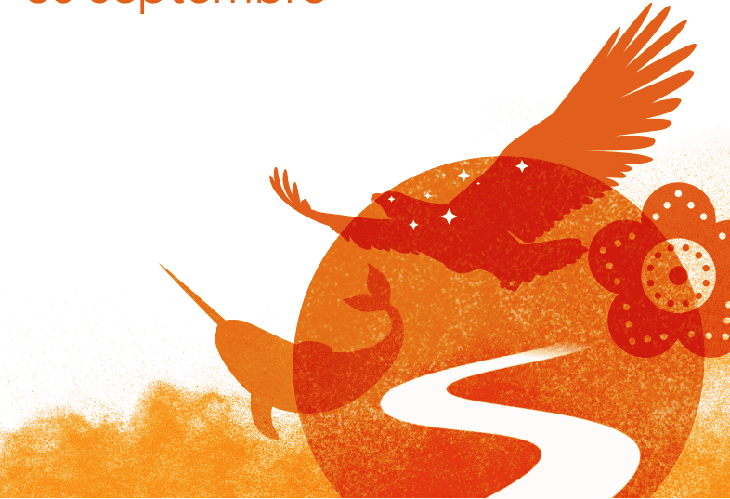
By Peter Bisson, SJ

Literary flair was not all that moved Anishinaabe Sister Eva Solomon CSJ to entitle her recent theological book “Come Dance with Me” (Novalis, 2022). Her title expresses the spiritual gifts of hope and joy that are strong with Indigenous people.
Indigenous peoples have been colonized for 500 years. Their world was taken away from them, and they have been forced to live in one not of their making, which has caused them no end of grave problems. Despite crushing burdens, they have not lost spirituality. As Mathieu Lavigne, director of Mission chez nous in Montreal pointed out in a recent webinar, Indigenous people are not only rooted below in their ancestors and creation but also above, in the Creator. This, I believe, is the source of their resilience and hope, their humour and their joy, and their recent growth and return to liveliness. It does not take away the problems, but it is a source of life that can foster resilience and creativity.
In the Church, we can be tempted to think that our Indigenous relations are an example of accompanying marginalized people. But under what perspective do they appear marginalized? And on the margins of what? Did not Jesus say that the last shall be first?
The Scriptures repeat in hundreds of ways that the centrality of God and of things of the Spirit are essential to living well. The Spiritual Exercises of St. Ignatius of Loyola say the same, and their culmination in the “Contemplation to Love Like God” sees God present and acting in all things, making them holy. Once we acknowledge the painful truth of having contributed to the burdens and injustice of colonization, the eyes of our understanding open and we start to recognize that more than needing accompaniment, Indigenous people point a way to God.
The contemporary philosopher Mohamed Amer Meziane (“Au bord des mondes,” Vues de l’esprit 2023) suggests that the first step toward dominating people and the Earth is to remove the divine from them. Indigenous people have not done that, but western cultures have. This removal makes it harder to find ways to God. With the centrality of things of the Spirit, Indigenous people and spiritualities are a prophetic reminder and support to the Church that we live in a divine milieu. Together we can better treat its holiness with the reverence and love it deserves, so we may more readily find and be found by God there.
“With the centrality of things of the spirit, Indigenous people and spiritualities are a prophetic reminder and support to the Church that we live in a divine milieu.”
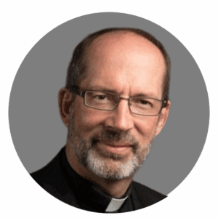
Fr. Peter Bisson, SJ, is a Jesuit priest in the Canadian Jesuit Province. He’s currently serving as associate assistant to the provincial for justice and Indigenous relations. He represents the Jesuits at the Our Lady of Guadalupe Circle, a network of indigenous and non-Indigenous leaders in the Catholic Church. He also served as provincial for the Jesuits in English Canada from 2012 to 2018.

