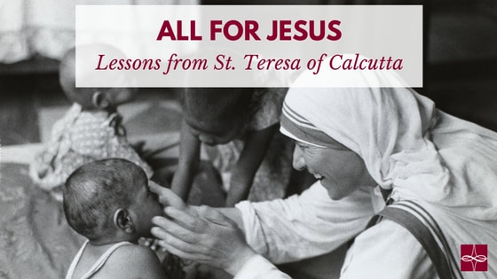
I have always admired Mother Teresa and her incredible mission, along with her reflective heart. I am so happy that I can now call upon her as St. Teresa of Calcutta, as she was just canonized on September 4, 2016! As I have studied and learned more about her, it seems as if St. Teresa of Calcutta would have dreaded knowing of her public canonization! She never wanted her writings or her work to bring attention to herself, but rather, she only desired to bring hearts to Jesus Christ. In her honor, I want to reflect on how her understanding of the world can bring our focus less on her and bring our hearts to Jesus.
St. Teresa of Calcutta taught us that God is in every living thing. She wrote, “Seeking the face of God in everything, everyone, all the time, and his hand in every happening; This is what it means to be contemplative in the heart of the world. Seeing and adoring the presence of Jesus, especially in the lowly appearance of bread, and in the distressing disguise of the poor” (St. Teresa of Calcutta, In the Heart of the World: Thoughts, Stories and Prayers).
Furthermore, St. Teresa of Calcutta taught us to seek Christ in every person we encounter. She recognized that each human being is created uniquely and beautifully. Each person is the face of God calling us to serve God by serving them. As Jesus said, “I was hungry and you gave me food, I was thirsty and you gave me drink, a stranger and you welcomed me, naked and you clothed me, ill and you cared for me, in prison and you visited me’” (Matthew 25:34-36).
When we love through the corporal and spiritual works of mercy as St. Teresa of Calcutta did, we are better able to see God more clearly in others. Imitating Christ by practicing the works of mercy also invites us to and see him more clearly in the Eucharist. Receiving Jesus in the Eucharist was essential for St. Teresa of Calcutta, as she knew Jesus was the fuel to teach her how to love others better and bring more souls into God’s embrace. She recognized that Christ’s love lives on in his humility of becoming our Eucharistic food and in the hearts of the poor, which includes the physically, mentally, and spiritually poor.
Bringing souls to Christ was a deep mission of St. Teresa of Calcutta. She consistently reflected over two of Jesus’ last words of his Passion – “I thirst” – and had them written next to the crucifixes in the chapels of the Missionaries of Charity (the religious order St. Teresa of Calcutta established in 1950) to remind her sisters that their mission was to satiate Christ’s thirsts for souls. When going to Jesus at the Cross, St. Teresa of Calcutta wanted us to feel his thirst and love for us. She believed that Christ wants us to rest in his love.
St. Teresa of Calcutta left behind a deep legacy of letting the world know just how loved and treasured we are. Her message teaches us that God loves us deeply and thirsts for us. When we know we are deeply loved by God, we can endure any suffering because we know joy is possible in the midst of carrying our own crosses. St. Teresa of Calcutta felt the pain of Jesus’ Passion deeply in her work in the slums of Calcutta and in the contemplations of her heart. She witnessed suffering first-hand taking care of the poorest of the poor and also experienced feelings of desolation and dryness in the spiritual life. Throughout it all, her joy remained full and she devoutly loved the Lord. St. Teresa of Calcutta is a beautiful witness of the mystery of suffering with Christ joyfully.
As we contemplate the great love, faith, and work of St. Teresa of Calcutta , we can pray with one of her favorite prayers: The Memorare. With such deep trust for God, she was consistently confident in the Lord’s ability to work miracles. Often, she prayed an “emergency novena,” praying nine Memorares in a row and a tenth in thanksgiving to God for a holy request. With confidence in our Lord, and thanksgiving for the testimony of St. Teresa of Calcutta, let us run to Jesus through Mary, that we may become steadfast in holiness, find joy in suffering, quench the thirst of Christ, and be confident in the good work that God is doing within us!
Remember, O most gracious Virgin Mary, that never was it known that anyone who fled to thy protection, implored thy help, or sought thine intercession was left unaided.
Inspired by this confidence, I fly unto thee, O Virgin of virgins, my mother; to thee do I come, before thee I stand, sinful and sorrowful. O Mother of the Word Incarnate, despise not my petitions, but in thy mercy hear and answer me.
St. Teresa of Calcutta, pray for us!
Alyce Shields is a teacher in Washington D.C.
Catholic Apostolate Center

