HOW TO PRAY THE GLORIOUS MYSTERIES OF THE ROSARY (WEDNESDAY & SUNDAY)

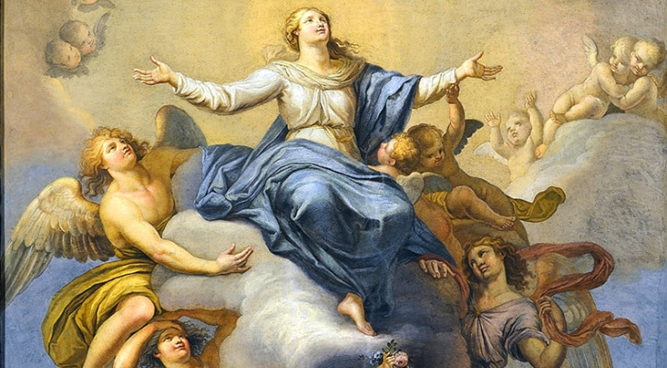
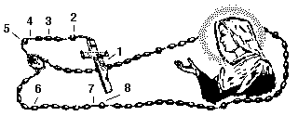
(Numbers other than the 10 Hail Marys refer to the numbers pointing to the beads in the above illustration.)

1.Make the Sign of the Cross saying “In the name of the Father, and of the Son, and of the Holy Spirit. Amen.”
Say the Apostles’ Creed: “I believe in God, the Father almighty creator of heaven and earth and in Jesus Christ, His only Son, our Lord, who was conceived by the Holy Spirit, born of the Virgin Mary, suffered under Pontius Pilate, was crucified, died, and was buried. He descended into hell. On the third day he rose again from the dead. He ascended into heaven and is seated at the right hand of God, the Father almighty. He will come again in glory to judge the living and the dead. I believe in the Holy Spirit, the Holy Catholic Church, the communion of saints, the forgiveness of sins, the resurrection of the body, and life everlasting. Amen.”

2) Say the Our Father: “Our Father, who art in heaven hallowed be thy name; thy kingdom come; thy will be done on earth as it is in heaven. Give us this day our daily bread and forgive us our trespasses as we forgive those who trespass against us; and lead us not into temptation but deliver us from evil. Amen.”
3) Say three Hail Marys for Faith, Hope, and Charity: “Hail Mary, full of grace. The Lord is with thee. Blessed art thou among women, and blessed is the fruit of thy womb, Jesus. Holy Mary, Mother of God, Pray for us sinners, Now and at the hour of our death. Amen.” – 3 times.

4) Say the Glory Be: “Glory be to the Father, and to the Son, and to the Holy Spirit. As it was in the beginning, is now, and ever shall be, world without end. Amen.”

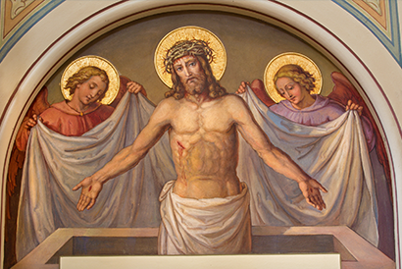

5) Announce “The First Glorious Mystery – The Resurrection of Jesus” and then say the Our Father.

6) Say ten Hail Marys while meditating on the Mystery.
- The body of Jesus is placed in the tomb on the evening of Good Friday.
- His soul descends into the realm of the dead to announce to the Just the tidings of their redemption.
- Fearing the body of Jesus will be taken, the chief priests place guards at the tomb.
- On the third day Jesus rises from the dead, glorious and immortal.
- The earth quakes as the angel rolls back the stone, the guards flee in terror.
- The holy women coming to anoint the body of Jesus are amazed and frightened to find the tomb open.
- An angel calms their fears: “He is not here. He has risen as He said.”
- Jesus appears to Mary Magdalen and Peter and two disciples on the way to Emmaus.
- That evening He appears to the apostles behind locked doors: “Peace be unto you… do not be afraid.”
- Jesus breathes on them and gives them the power to forgive sin.
Spiritual Fruit: Faith

7) Glory Be
Glory be to the Father, and to the Son, and to the Holy Spirit. As it was in the beginning, is now, and ever shall be, world without end. Amen.
Oh My Jesus
O my Jesus, forgive us our sins. Save us from the fires of hell. Lead all souls into heaven, especially those in most need of thy mercy. Amen.

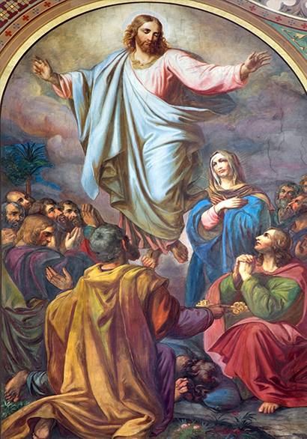

8) Announce “The Second Glorious Mystery – The Ascension of Our Lord into Heaven” and then say the Our Father.
Say ten Hail Marys while meditating on the Mystery.
- Jesus remains on earth forty days after His Resurrection to prove He has truly risen from the dead.
- He commissions the apostles to preach the gospel to every creature, and promises to be with them forever.
- He will not leave them orphans, but will send the Holy Spirit to enlighten and strengthen them.
- Jesus proceeds to Mt. Olivet accompanied by His mother and the apostles and disciples.
- Extending His pierced hands over all in a last blessing, He ascends into heaven.
- As He ascends a cloud takes Him from their sight.
- Jesus ascends to take His place at the right hand of the Father.
- What jubilation there must be amid the angels of heaven at the triumphant entry of Jesus.
- The wounds in His glorified body are an endless plea before the Father on our behalf.
- The disciples leave Mt. Olivet and “return to Jerusalem with great joy.”
Spiritual Fruit: Christian Hope
Glory Be
Glory be to the Father, and to the Son, and to the Holy Spirit. As it was in the beginning, is now, and ever shall be, world without end. Amen.
Oh My Jesus
O my Jesus, forgive us our sins. Save us from the fires of hell. Lead all souls into heaven, especially those in most need of thy mercy. Amen.

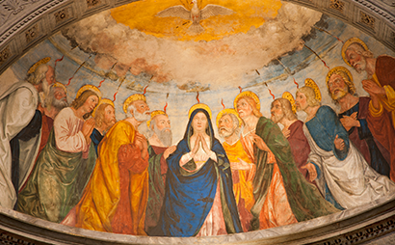

Announce “The Third Glorious Mystery – The Holy Spirit comes upon Mary and the Apostles” and then say the Our Father.
Say ten Hail Marys while meditating on the Mystery.
- The apostles are gathered in the upper room where Jesus had held the Last Supper.
- They are persevering in prayer with Mary the mother of Jesus.
- A sound comes from heaven like the rush of a mighty wind, and it fills the whole house.
- The Holy Spirit descends on each of them in the form of tongues of fire.
- Filled with the Gifts of the Holy Spirit, they are enlightened and strengthened to spread the Gospel.
- Having lost all fear of the Jewish leaders, the apostles boldly preach Christ crucified.
- The multitudes are confounded because everyone hears them speak in their own tongue.
- The Holy Spirit comes upon the Infant Church never to leave it.
- That first day Peter goes forth to preach and baptizes three thousand.
- The feast of Pentecost is the birthday of the Church, for on that day it begins to grow.
Spiritual Fruit: Gifts of the Holy Spirit
Glory Be
Glory be to the Father, and to the Son, and to the Holy Spirit. As it was in the beginning, is now, and ever shall be, world without end. Amen.
Oh My Jesus
O my Jesus, forgive us our sins. Save us from the fires of hell. Lead all souls into heaven, especially those in most need of thy mercy. Amen.

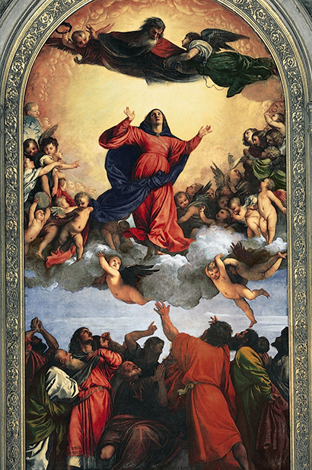

Announce “The Fourth Glorious Mystery – The Assumption of Mary” and then say the Our Father.
Say ten Hail Marys while meditating on the Mystery.
- After the apostles have dispersed, the Blessed Mother goes to live with John, the beloved disciple.
- Mary lives many years on earth after the death of Christ.
- She is a source of comfort, consolation and strength to the apostles.
- As she had nourished the infant Jesus, so she nourishes spiritually the infant Church.
- Mary dies, not of bodily infirmity, but is wholly overcome in a rapture of divine love.
- Her body as well as her soul is taken up into heaven.
- After her burial the apostles go to the tomb and find only fragrant lilies.
- Jesus does not permit the sinless body of His Mother to decay in the grave.
- Corruption of the body is an effect of original sin from which Mary is totally exempted.
- The bodies of all humanity, at the last judgment, will be brought back and united again to the soul.
Spiritual Fruit: Desire for Heaven
Glory Be
Glory be to the Father, and to the Son, and to the Holy Spirit. As it was in the beginning, is now, and ever shall be, world without end. Amen.
Oh My Jesus
O my Jesus, forgive us our sins. Save us from the fires of hell. Lead all souls into heaven, especially those in most need of thy mercy. Amen.

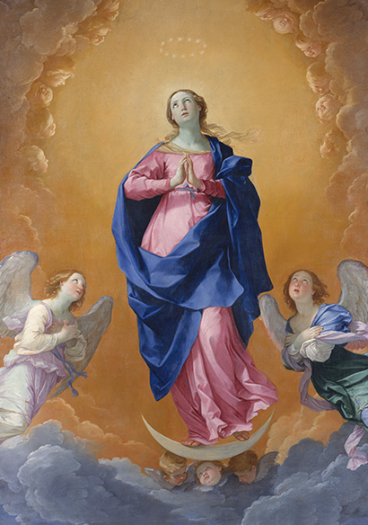

Announce “The Fifth Glorious Mystery – The Coronation of Mary as Queen of Heaven and Earth” and then say the Our Father.
Say ten Hail Marys while meditating on the Mystery.
- As Mary enters heaven, the entire court of heaven greets with joy this masterpiece of God’s creation.
- Mary is crowned by her divine Son as Queen of heaven and earth.
- More than we can ever know the Hearts of Jesus and Mary overflow with joy at this reunion.
- Only in heaven will we know the great majesty of that coronation, and the joy it gave to the angels and saints.
- Even the angels, who by nature are greater than humans, hail Mary as their Queen.
- Mary shares so fully in the glory of Christ because she shared so fully in His suffering.
- Only in heaven will we see how central is the role of Mary in the divine plan of redemption.
- The angels and saints longed for the coming of her whose heel crushes the head of the serpent.
- Mary pleads our cause as a most powerful Queen and a most merciful and loving Mother.
- A great sign appeared in heaven; a woman clothed with the sun, the moon under her feet, and on her head a crown of twelve stars.
Spiritual Fruit: Grace of Final Perseverance
Glory Be
Glory be to the Father, and to the Son, and to the Holy Spirit. As it was in the beginning, is now, and ever shall be, world without end. Amen.
Oh My Jesus
O my Jesus, forgive us our sins. Save us from the fires of hell. Lead all souls into heaven, especially those in most need of thy mercy. Amen.

Closing Prayers
Hail Holy Queen
Hail Holy Queen, Mother of Mercy, our Life, our Sweetness, and our hope. To thee do we cry, poor banished children of Eve. To thee do we send up our sighs, mourning and weeping in this vale of tears. Turn then most gracious advocate, Thine eyes of mercy toward us, and after this, our exile, show unto us, the blessed fruit of thy womb, Jesus. O clement, O loving, O sweet Virgin Mary. Pray for us O Holy Mother of God, That we may be made worthy of the promises of Christ. Amen.
Final Prayer
Let us pray. O God, whose only begotten Son, by His life, death, and resurrection, has purchased for us the rewards of eternal life, grant, we beseech Thee, that meditating upon these mysteries of the Most Holy Rosary of the Blessed Virgin Mary, we may imitate what they contain and obtain what they promise, through the same Christ Our Lord. Amen.

Make the Sign of the Cross.

