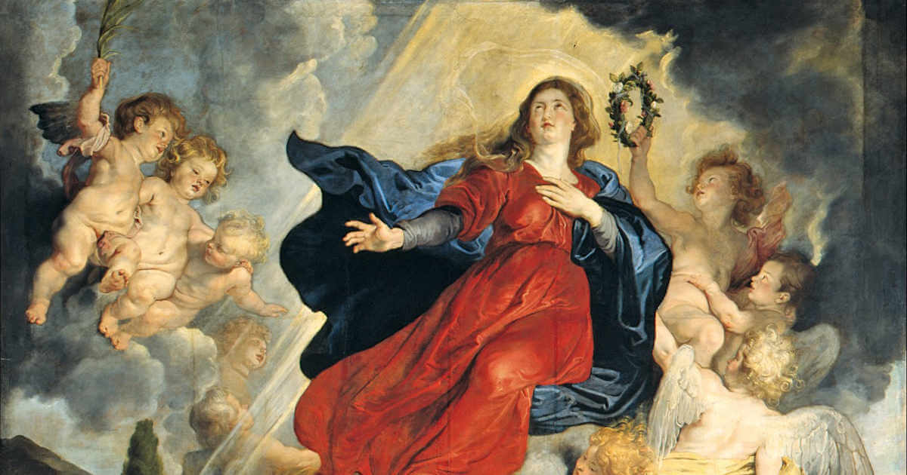

COMMENTARY ON THE READINGS
THE ASSUMPTION OF THE BLESSED VIRGIN MARY

Commentary on Revelation 11:19; 12:1-6,10; 1 Corinthians 15:20-26; Luke 1:39-56

Today’s feast celebrates the special place that Mary has in the life of the Church. This place is first of all defined by her being chosen to be the mother of Jesus, his only human parent. This alone gives her a uniqueness which is shared by no other person who has ever lived.
As with the case of Jesus’ resurrection, we need to look at the meaning of what the feast is about rather than being too literal in our understanding of how it is described. It is probably not helpful to try to imagine that, as soon as Mary’s dead body was laid in the grave, it immediately, as it were, escaped from its earthly darkness and floated up ‘body and soul’ into ‘heaven’.

By using the image “assumed body and soul into heaven”, what is really being said is that Mary, because of the dignity of her motherhood and her own personal submission to God’s will at every stage of her life, takes precedence over everyone else in the sharing of God’s glory—which is the destiny of all of us who die united with Christ her Son.
She remains, of course, fully a human being and thus lower in dignity than her Son and much closer to us. With us, but leading us, she stands in adoration of Father, Son and Holy Spirit. She cannot, even in glory, be given in any way the worship that is proper to the Persons of the Trinity. What she can do is to intercede for us in our needs, offering her human prayers on our behalf. This is something our non-Catholic Christian brothers and sisters do not always understand, and perhaps we Catholics have by our words and actions given a distorted idea of the place of Mary in our Christian living.

Mary’s role is well described in the Catechism of the Catholic Church:
“By her complete adherence to the Father’s will, to his Son’s redemptive work, and to every prompting of the Holy Spirit, the Virgin Mary is the Church’s model of faith and charity. Thus she is a ‘pre-eminent and…wholly unique member of the Church’; indeed, she is the ‘exemplary realisation’ (Latin: typus) of the Church.” (Section 967)

Today’s Gospel is the story of Mary’s visitation to her cousin Elizabeth when both were expecting their first child. The story contains most of the elements which contribute to the status we give to Mary in our Church.

First, we see Mary setting out with haste from Nazareth to a small town in the hills of Judea, not far from Jerusalem (where Zechariah served as a priest in the Temple). She went to visit her older cousin, Elizabeth, who was pregnant with the child we know as John the Baptist. Mary herself, of course, is carrying her own child, Jesus. It is highly significant that it is Mary and Jesus who go to visit Elizabeth and John. Already in the womb, Jesus is showing that urge to serve rather than be served. Mary, too, shares that urge. And, at the presence of Jesus and his mother, the child in Elizabeth’s womb jumps for joy.
Elizabeth, filled with the Holy Spirit, excitedly bursts out into praise. She recognises the special position of Mary and her Son:
Blessed are you among women, and blessed is the fruit of your womb.

Mary is indeed unique and blessed in being chosen to be the mother of our saving King and Lord. Elizabeth is deeply moved that it is Jesus and his Mother that come to her and John:
And why has this happened to me, that the mother of my Lord comes to me?
And yet that is what is happening to each of us all the time, and especially in every celebration of the Eucharist, when the Lord comes to us in the sharing of his Word and in the breaking of the bread and our sharing in the cup.

And there is a special word of praise for Mary also:
Blessed is she who believed that there would be a fulfilment of what was spoken to her by the Lord.

This brings us to the second characteristic of Mary—her faith and total trust in God. That was expressed in her fiat (“Let it be done to me…”), when, even though not fully understanding what was being asked of her, she unconditionally accepted to submit to God’s plan.

It is now Mary’s turn to sing God’s praises in the lovely song we call the Magnificat, which the Church sings at its evening prayer every day. It is full of reflections on what makes Mary great in the eyes of God:
He has looked with favour on the lowliness of his servant.

Mary was a simple unmarried girl living in obscurity in a small town in an out of the way Roman province. About the town, Nathanael asked rather cynically when told where Jesus came from:
Can anything good come from Nazareth? (John 1:46)

But in the New Covenant, reflecting God’s own bias, it is the lowly and obscure who are specially favoured. Mary’s greatness does not come from her social status; that has no relevance whatever in God’s eyes, except in so far as those at the bottom of the social ladder tend to be denied a fair share of this world’s goods.

From now on all generations will call me blessed.
This is not a statement made in arrogance, but in humble thanksgiving and, of course, has been true since the day it was uttered. It was indeed an extraordinary grace to be chosen to be the mother of the world’s Saviour. Why Mary? we might ask, and Mary herself would be the first to agree. But she rejoices and is deeply grateful for being chosen for this privilege.
Her being chosen is simply another sign of God’s desire that the poor, the weak, the marginalized, the exploited and discriminated against in this world should be the special recipients of God’s love and care. Mary expresses this in the last part of her song:
He has shown strength with his arm;
He has scattered the proud in the thoughts of their hearts.
He has brought down the powerful from their thrones,
and lifted up the lowly;
He has filled the hungry with good things,
and sent the rich away empty.

The rich and powerful of Mary’s day: where are they now? Who were they? For the most part they have disappeared from history and memory, while the little girl of Nazareth is still celebrated round the world.

But Mary’s greatness does not stop at the graces and privileges which were showered on her. These, after all, were purely passive in the sense they were gifts given to her. In a telling scene in the Gospel, a woman who had been listening to Jesus suddenly cried out in a loud voice:
Blessed is the womb that bore you and the breasts that nursed you! (Luke 11:27)

In our own language today we might say: “May God bless the mother who produced such a wonderful son as you!” And there is a deep truth here, namely, the influence that Mary (and Joseph, too) actually had in the formation of her Son. But Jesus immediately picked up the woman’s words and said:
No, blessed rather are those who hear the word of God and obey it. (Luke 11:28)

In other words, it is not the graces that God gives us which make us great, but the manner in which we receive and respond to them.

Mary’s greatness was not just in being chosen to be Jesus’ mother, but in her total acceptance of that responsibility in faith and trust—accepting blindly all that it might entail. And, indeed, she had no idea the price she would have to pay to be the mother of Jesus. But again, like her Son, she had emptied herself into total service to his Father and today we celebrate her reward, her being raised to the highest place among the human race.

This is indirectly expressed in the Second Reading from the First Letter to the Corinthians where Paul is speaking of the resurrection of Christ as crucial to the validity of our Christian faith. And Christ, the Son of God made flesh who died on the cross, is indeed the very first among the risen, seated at the right hand of his Father. He is, in Paul’s words:
…the first fruits of those who have died…
But further on Paul says:
…for as all die in Adam, so all will be made alive in Christ. But each in their own order.
Jesus is first of all, but next in order surely comes his Mother.

The First Reading from the Book of Revelation has clearly been chosen as a symbolic description of Mary in glory. There is first a brief vision of God’s Temple in the New Jerusalem opening and revealing the Ark of the Covenant within. The original Ark, a chest made of acacia wood, contained the tablets of the Law and was kept in the Holy of Holies as the pledge of God’s promise—his covenant—to be with his people. But this is the Ark of the New Covenant, the permanent home of God among his people, the Risen Jesus in his Body, the Church. On today’s feast, the image is applied to Mary, who bore the maker of the New Covenant within herself. And so she is called in the Litany of Our Lady, “Ark of the Covenant”.

Next, there is a much longer description of the vision of a woman appearing from heaven. The woman is Israel, from whom was born the Messiah and the community which believed in him. The description of the woman is often applied to Mary in statues and images:
Clothed with the sun, the moon under her feet…on her head a crown of twelve stars.
The woman is described as being pregnant, crying out in birth pangs and in the agony of giving birth. This recalls the words of God to our first parents after the fall, telling of the pain that would accompany childbirth. But the child being born is the Messiah, seen both as an individual and leader of the new Israel. The mother who bears him is suffering from persecution and oppression.

There follows an apocalyptic description of a dragon threatening to devour the child as soon as it is born. The dragon (along with the serpent) was seen in Jewish tradition as representing the power of evil, the enemy both of God and his people. Its tail sweeping a third of the stars from the sky is an allusion to the fall of those angels who sided with Lucifer. Nevertheless, the child is born. He is a son, who will rule all the nations with a rod of iron. He is the promised Messiah. However, he is described as being immediately snatched away and taken up to God. This refers to the ascension and triumph of the Messiah which follows the dragon’s fall.

Meanwhile, the woman, the mother, flees into the wilderness, the traditional refuge for the persecuted. God has prepared a place there for her where she can be nourished for 1,260 days, which corresponds to the time of the persecution.

It must be first of all emphasised that the writer is not directly thinking of Mary here, and clearly, not all of this passage can be directly applied to her. But Mary is the mother of Jesus, who in his Body is the continuation of God’s presence among us. Mary now stands, glorious and bejewelled, in the presence of her Son and his Father with the Spirit.

Today we join in her happiness. We look forward to the day when we too can share it with her. In the meantime, we ask her to remember us as we continue our journey on earth and to intercede for us with her Son, that we may remain faithful to our call as faithful disciples. May we know God’s will for us at all times and, like Mary, say our unconditional Yes to what he wants for us.

