RUBLEV’S TRINITY ICON
The following information is taken from the British Association of Iconographers www.bai.org.uk/rublevs-trinity-icon
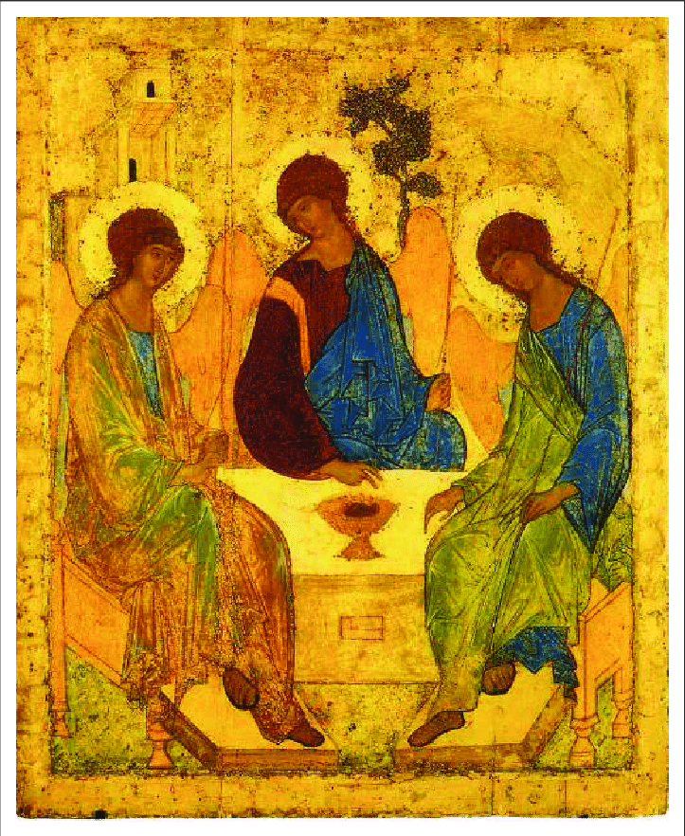

Rublev’s Trinity Icon was painted between 1408 and 1425 and is the supreme example of the Moscow School of iconography.
It is thought that Rublev lived between 1370 and 1430. Rublev was at one time a monk in one of St. Sergius’s monasteries dedicated to the Holy Trinity.

ORIGIN OF THE TRINITY ICON
In 1408, the monastery of the Holy Trinity of St. Sergius was completely destroyed, but Blessed Nikon, with the help of the Princes of Moscow, set about reconstructing it according to its original plans, expanding it north eastwards as well.
Rublev received the commission to paint an icon of the Holy Trinity to give the monks something peaceful to aid contemplation in the midst of a world of turmoil and violence. As someone said: “An icon represents a world that is spirit, yet has lost none of its flesh. It is a presence both human and divine. It is an art with grace. It helps us to find words to speak with, paths to walk on, even when the future seems to be ominous and menacing at every turn. “Rublev’s icon reflects this.
He was old when he received the commission and so had behind him much work experience (and prayer) that now held him in good stead for the task he received and achieved.

WHAT WE SEE IN THIS ICON
The icon depicts the Holy Trinity by representing the Biblical scene of three men appearing to Abraham at the Oak of Mambre. To show they belong to the heavenly world, they are depicted as three winged angels, but the circumstances of their appearance are passed over in silence.
Rublev’s icon of the Holy Trinity
The cosmos is represented in the background by a mountain and tree – the tree of life – and Abraham’s house is seen, because the main focus lies not in the Biblical meaning but in its dogma, or theological teaching. Just before Rublev’s time the historical aspect of the event was more dominant, as Sarah was often depicted serving the calf, objects on the table, and Abraham entertaining the guests or serving them with Sarah. But in Rublev’s icon the treatment is reduced to the essentials, because it excludes these other details. The visiting angels sit in quiet conversation, the table becomes an altar with only the Eucharistic cup on it, and the oak tree and house become symbols. Geometrical structure, especially circles, creates a unity allowing for representing the Trinity as a movement of unity and love.
According to Ouspensky, the angels are grouped in order of symbols of faith, from left to right, God the Father, God the Son, God the Holy Spirit. The angel on the left wears a pale blue cloak with brown and blue-green highlights. He represents the Father blessing the chalice in a gesture indicating His will for the sorrowful mission of His Son as assigned to Him. The centre angel wears a purple undergarment and blue cloak, the customary colours used for depicting Christ on icons. His priestly function is symbolised by His wearing a stole and blessing the cup in a restrained gesture, indicating acceptance in humility and obedience to offer Himself as a sacrifice. The right hand angel is clothed in the principal colour of green, which Dioynsius, the Areopagite says signifies ‘youth, fullness of powers’ – thus suggesting properties of the Holy spirit. The elongated bodies of the angels are 14 times the head (instead of the normal 8). There is an invisible circle enfolding the three angels, and, wherever one looks, echoes of circles can be seen. The overall colour in this icon, with its tranquil blues and green, overlain with paler tones, combined with soft ivory white producing a transparent effect, shows forth harmony, unity and concord. This, in turn, is echoed in the forms and lines in the icon. As Ouspensky says, This icon, with its inexhaustible content, its harmonious composition, majestic calm, figures of the angels conversing in silence and the light joyous summer colours, could only be the creation of a man who has stilled, in his soul, all agitation and doubt, and has been illuminated by the light and knowledge of God.’
In the Orthodox Church, from which icons originate and are still much in use, there is no specific Feast of the Trinity or Trinity Sunday. The Trinity is not only used as a formula and in prayer in the services but is linked with the Holy Spirit at Pentecost. Hence the icon of Rublev would come much to mind at the Feast of Pentecost.

