PAUSE & PRAY FOR MISSION
May 24th is the Solemnity of Pentecost, one of the most important celebrations in our entire liturgical year. We pray together for a renewed outpouring of the Holy Spirit.

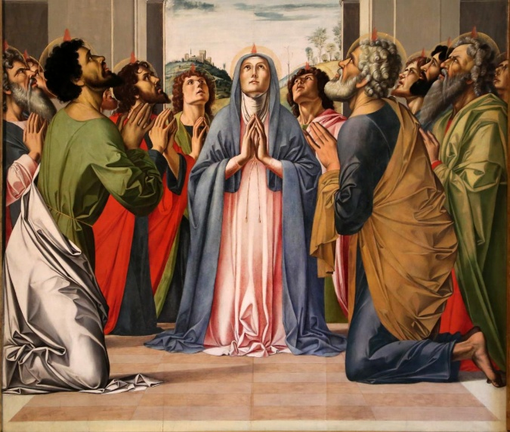
Loving Father, pour out your Holy Spirit anew upon your Church.
Awaken within us the charisms
you gifted us with in Baptism,
and stir them into flame for the mission of the Gospel.

Send us forth as missionary disciples of Jesus.
Give us the courage to proclaim your truth with joy,
to witness to your mercy with humility,
and to bring the hope of the Resurrection into the world.

Open our eyes to see where you are calling us to serve.
Lead us beyond comfort and fear,
so that in our homes, workplaces, schools, and communities we may reveal your love through lives of holiness and charity.

Teach us to sanctify the world through faithful witness and loving service.
Fill our hearts with the fire of Pentecost,
so that our words and actions
may draw others to know and follow Jesus.

Come Holy Spirit,
fill the hearts of your faithful
and kindle in them the fire of your love.
Send forth your Spirit and they shall be created.
And You shall renew the face of the earth.

O God, who by the light of the Holy Spirit,
did instruct the hearts of the faithful,
grant that by the same Holy Spirit

