NOVENA FOR ORDINATION TO THE PRIESTHOOD OF JESUS CHRIST
WE PRAY FOR DEACON DAVIL BASIL CSB

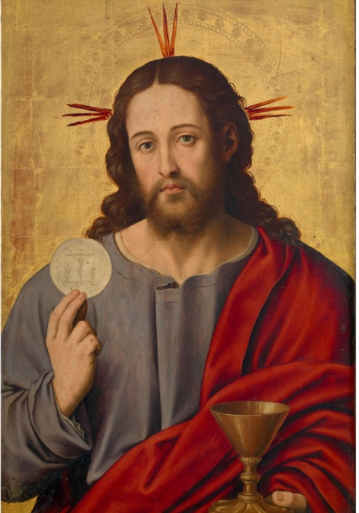

DAY ONE: DEVOTION IN CELEBRATING THE MASS
Ordination Novena for Deacon David Basil CSB
May David celebrate every Mass that he offers with devotion, care, and a desire to conform his life to the self-offering of Christ on the Cross and in the Eucharist.
Novena prayer:
Lord Jesus, we thank you for the gift of the priesthood and for calling our brother David to serve The Congregation of St. Basil here in the Diocese of London as your priest. May the graces of his ordination conform him ever more closely to you as he seeks to imitate you, the Good Shepherd. Give him a tender love for all whom he serves, fervor in celebrating the Sacraments, compassion for sinners, and a deep desire to lead all people to the heart of the Father. Give him the strength to live up to the dignity of his high calling. May the example of his life reveal the love and mercy of your heart and inspire others to give themselves more fully to you and to the service of your church. Amen.
Our Father...
Hail Mary...
Glory Be...

DAY TWO: FILIAL LOVE FOR THE BISHOP AND HIS LEGITIMATE SUPERIOR
Ordination Novena for Deacon David Basil CSB
May David pledge sincere filial obedience to our bishop and his legitimate superior and may both our bishop and his superior be true fathers to him as he undertakes his priestly ministry.
Novena prayer:
Lord Jesus, we thank you for the gift of the priesthood and for calling our brother David to serve The Congregation of Saint Basil here in the Diocese of London as your priest. May the graces of his ordination conform him ever more closely to you as he seeks to imitate you, the Good Shepherd. Give him a tender love for all whom he serves, fervor in celebrating the Sacraments, compassion for sinners, and a deep desire to lead all people to the heart of the Father. Give him the strength to live up to the dignity of his high calling. May the example of his life reveal the love and mercy of your heart and inspire others to give themselves more fully to you and to the service of your church. Amen.
Our Father...
Hail Mary...
Glory Be...

DAY THREE: ATTENTION TO THE WORD OF GOD
Ordination Novena for Deacon David Basil CSB
May David give pride of place to Sacred Scripture in his prayer and continuing formation, allowing it to shape his heart, his preaching, and his outreach to his parishioners.
Novena prayer:
Lord Jesus, we thank you for the gift of the priesthood and for calling our brother David to serve The Congregation of St. Basil here in the Diocese of London as your priest. May the graces of his ordination conform him ever more closely to you as he seeks to imitate you, the Good Shepherd. Give him a tender love for all whom he serves, fervor in celebrating the Sacraments, compassion for sinners, and a deep desire to lead all people to the heart of the Father. Give him the strength to live up to the dignity of his high calling. May the example of his life reveal the love and mercy of your heart and inspire others to give themselves more fully to you and to the service of your church. Amen.
Our Father...
Hail Mary...
Glory Be...

DAY FOUR: PERSEVERANCE IN PURITY OF HEART
Ordination Novena for Deacon David Basil CSB
May David remain pure in heart, not only in his commitment to celibacy and chastity, but in all his thoughts, motives, and actions, that he may see all things and all people through the eyes of Christ.
Novena prayer:
Lord Jesus, we thank you for the gift of the priesthood and for calling our brother David to serve The Congregation of St. Basil here in the Diocese of London as your priest. May the graces of his ordination conform him ever more closely to you as he seeks to imitate you, the Good Shepherd. Give him a tender love for all whom he serves, fervor in celebrating the Sacraments, compassion for sinners, and a deep desire to lead all people to the heart of the Father. Give him the strength to live up to the dignity of his high calling. May the example of his life reveal the love and mercy of your heart and inspire others to give themselves more fully to you and to the service of your church. Amen.
Our Father...
Hail Mary...
Glory Be...

DAY FIVE: CARE IN CELEBRATING THE SACRAMENTS
Ordination Novena for Deacon David Basil CSB
May David celebrate all the sacraments he offers with reverence and with a true desire to bring the love and grace of Jesus Christ to his flock.
Novena prayer:
Lord Jesus, we thank you for the gift of the priesthood and for calling our brother David to serve The Congregation of St. Basil here in the Diocese of London as your priest. May the graces of his ordination conform him ever more closely to you as he seeks to imitate you, the Good Shepherd. Give him a tender love for all whom he serves, fervor in celebrating the Sacraments, compassion for sinners, and a deep desire to lead all people to the heart of the Father. Give him the strength to live up to the dignity of his high calling. May the example of his life reveal the love and mercy of your heart and inspire others to give themselves more fully to you and to the service of your church. Amen.
Our Father...
Hail Mary...
Glory Be...

DAY SIX: MENTAL AND EMOTIONAL HEALTH
Ordination Novena for Deacon David Basil CSB
May David be preserved in his mental and emotional well-being, and may he find healing and wholeness in Christ and through the support and counsel of others in his times of struggle.
Novena prayer:
Lord Jesus, we thank you for the gift of the priesthood and for calling our brother David to serve The Congregation of St. Basil here in the Diocese of London as your priest. May the graces of his ordination conform him ever more closely to you as he seeks to imitate you, the Good Shepherd. Give him a tender love for all whom he serves, fervor in celebrating the Sacraments, compassion for sinners, and a deep desire to lead all people to the heart of the Father. Give him the strength to live up to the dignity of his high calling. May the example of his life reveal the love and mercy of your heart and inspire others to give themselves more fully to you and to the service of your church. Amen.
Our Father...
Hail Mary...
Glory Be...

DAY SEVEN: CONFORMITY TO THE SACRED HEART
Ordination Novena for Deacon David Basil CSB
May David be truly conformed to the Sacred Heart of Jesus by radiating his mercy toward sinners and receiving all people with love.
Novena prayer:
Lord Jesus, we thank you for the gift of the priesthood and for calling our brother David to serve The Congregation of St. Basil here in the Diocese of London as your priest. May the graces of his ordination conform him ever more closely to you as he seeks to imitate you, the Good Shepherd. Give him a tender love for all whom he serves, fervor in celebrating the Sacraments, compassion for sinners, and a deep desire to lead all people to the heart of the Father. Give him the strength to live up to the dignity of his high calling. May the example of his life reveal the love and mercy of your heart and inspire others to give themselves more fully to you and to the service of your church. Amen.
Our Father...
Hail Mary...
Glory Be...

DAY EIGHT: SUPPORT FROM HIS FLOCK
Ordination Novena for Deacon David Basil CSB
May David be preserved from discouragement and loneliness through the love and friendship of his family, friends, and those he serves.
Novena prayer:
Lord Jesus, we thank you for the gift of the priesthood and for calling our brother David to serve The Congregation of St. Basil here in the Diocese of London as your priest. May the graces of his ordination conform him ever more closely to you as he seeks to imitate you, the Good Shepherd. Give him a tender love for all whom he serves, fervor in celebrating the Sacraments, compassion for sinners, and a deep desire to lead all people to the heart of the Father. Give him the strength to live up to the dignity of his high calling. May the example of his life reveal the love and mercy of your heart and inspire others to give themselves more fully to you and to the service of your church. Amen.
Our Father...
Hail Mary...
Glory Be...

DAY NINE: STRENGTH IN WEAKNESS AND TEMPTATION
Ordination Novena for Deacon David Basil CSB
May David find strength and consolation in times of weakness and temptation, especially through the love and prayers of Mary, the mother of Priests.
Novena prayer:
Lord Jesus, we thank you for the gift of the priesthood and for calling our brother David to serve The Congregation of St. Basil here in the Diocese of London as your priest. May the graces of his ordination conform him ever more closely to you as he seeks to imitate you, the Good Shepherd. Give him a tender love for all whom he serves, fervor in celebrating the Sacraments, compassion for sinners, and a deep desire to lead all people to the heart of the Father. Give him the strength to live up to the dignity of his high calling. May the example of his life reveal the love and mercy of your heart and inspire others to give themselves more fully to you and to the service of your church. Amen.
Our Father...
Hail Mary...
Glory Be...

