PRAYERS FOR PEACE IN THIS TIME OF WAR

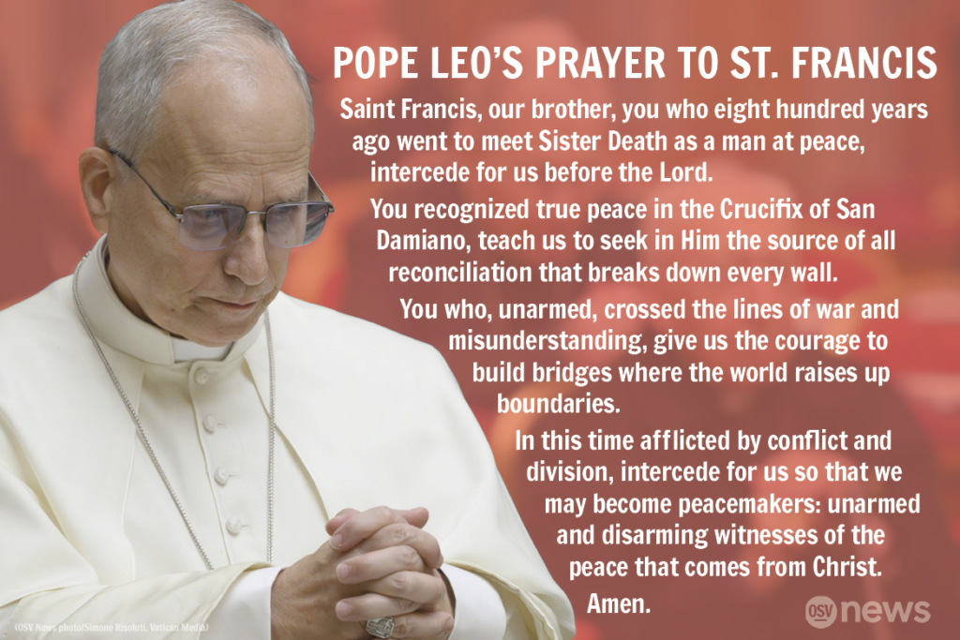

PEACE IN THE MIDDLE EAST
God of mercy and compassion,
of grace and reconciliation,
pour your power upon all your children in the Middle East:
Jews, Muslims and Christians,
Palestinians and Israelis.
Let hatred be turned into love, fear to trust, despair to hope,
oppression to freedom, occupation to liberation,
that violent encounters may be replaced by loving embraces,
and peace and justice could be experienced by all.
Reverend Said
BRING JUSTICE AND PEACE
God of all creation, bring justice and peace to our world.
Teach us to be peacemakers. Guide us in our pursuit of
justice and the common good. Inspire us to welcome all, forgive
all, and love all. Direct us as we walk in the shadow of Jesus: the
Way, the Truth, and the Life. Inspire us to perceive the world
through your eyes, that we might find hope and joy each day,
supportive of each other, for the sake of your Kingdom.
Author Unknown
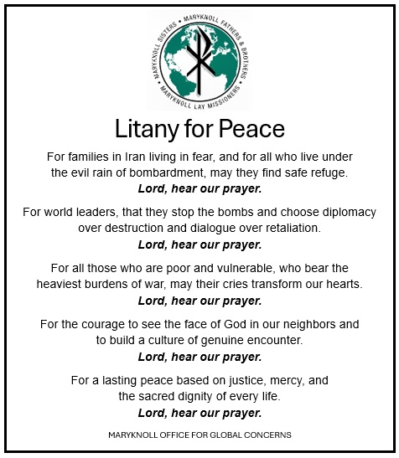

PRAYER OF ST. FRANCIS OF ASSISI (PRAYER FOR PEACE)
Lord, make me an instrument of your peace:
where there is hatred, let me sow love;
where there is injury, pardon;
where there is doubt, faith;
where there is despair, hope;
where there is darkness, light;
where there is sadness, joy.
O divine Master, grant that I may not so much seek
to be consoled as to console,
to be understood as to understand,
to be loved as to love.
For it is in giving that we receive,
it is in pardoning that we are pardoned,
and it is in dying that we are born to eternal life.

A MENNONITE PRAYER FOR PEACE IN RESPONSE TO THE IRAN WAR
As followers of Jesus Christ, we are deeply saddened by the violence and destruction unfolding in our world. The bombing of Iran and the escalating tensions in the region remind us of the fragile nature of peace and the immense cost of war.
We affirm the sacred dignity of every human life.
We reject hatred and dehumanization that occurs in the name of seeking peace.
We grieve every life lost.
We pray for families who are mourning.
We ask you to protect civilians, children and all who are most vulnerable from further harm.
While nations wrestle with complex political and security concerns, we believe Christ calls us to be agents of reconciliation, truth and peace.
We commit ourselves to pray for wisdom for leaders, protection for the innocent, comfort for those who grieve, and restraint that prevents further bloodshed. May God’s justice and mercy guide all nations toward lasting peace.
Holy Spirit, bring comfort where there is fear, courage where there is despair, and hope where darkness feels overwhelming. Amen.

