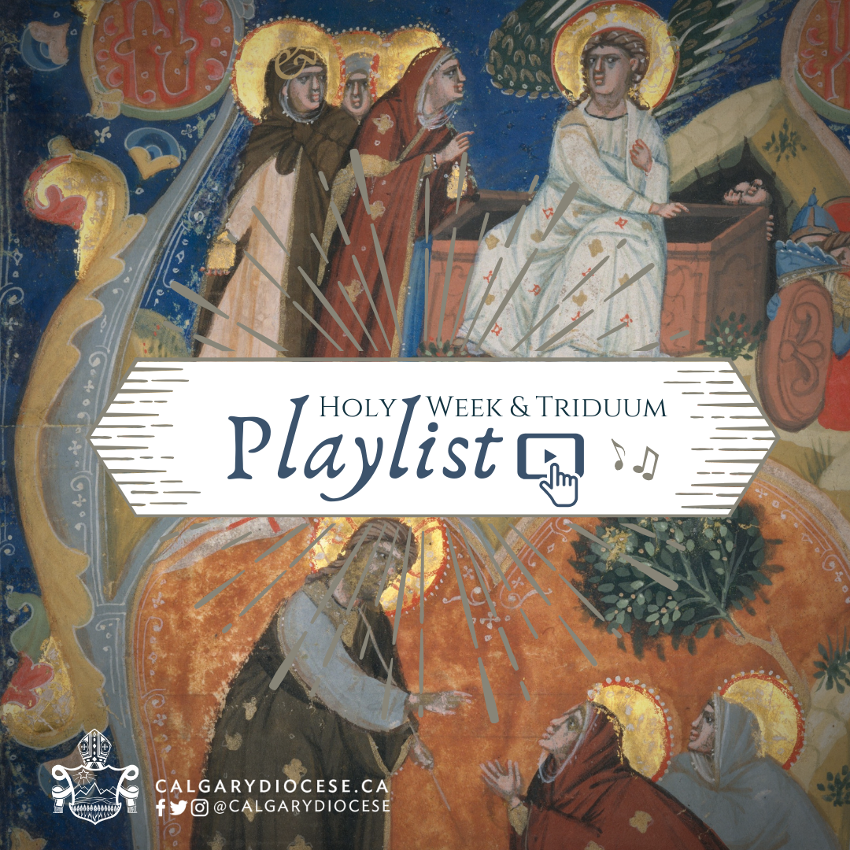

Triduum Sacred Music Playlist
This is what is available through the website of the Diocese of Calgary
Access at catholicyyc.ca/blog/triduum-sacred-music-playlist

Holy Thursday
​Play YouTube Playlist
Play Spotify Playlist
- Ubi Caritas (Chant) | Video | Sheet Music
- Tantum Ergo (Chant) | Video | Sheet Music
- O Sacrum Convivium (Roberto Remondi) | Video | Sheet Music
- Ave Verum Corpus (William Byrd) | Video | Sheet Music
- Godhead Here in Hiding (G. Manley Hopkins/Thomas Aquinas) | Video | Sheet Music
- Panis Angelicus (Lambilotte) | Video | Sheet Music
- My Song is Love Unknown (John Ireland) | Video 1 | Video 2 | Sheet Music
- Adoro te Devote (Chant) | Video | Sheet Music
- A New Commandment (Tallis) | Video | Sheet Music
- Ubi Caritas (Garau) | Video | Sheet Music
- Stay with me (Taize) | Video | Sheet Music
- Ubi Caritas (Gjielo) | Video | Sheet Music
- Ubi Caritas (Duruffle) | Video | Sheet Music
- Ave Verum Corpus (Mozart) | Video | Sheet Music
- Verbum Caro (Hassler) | Video | Sheet Music
- Una Hora - Responsory (Chant) | Video | Sheet Music
- Go to dark Gethsemane (Montgomery/Bach) | Video | Sheet Music
- And Now, O Father! (William Bright/UNDE ET MEMORES) | Video | Sheet Music
- Now, My Tongue, The Mystery Telling​ (GRAFTON) | Video 1 | Sheet Music
- Bread of the World in Mercy Broken (Ralph Vaughan) | Video | Sheet Music
- Mandatum (Composer) | Video | Sheet Music
- Litany of Humility (Composer) | Video | Prayer

Good Friday
​​​Play YouTube Playlist for Good Friday
- O Vos Omnes (Victoria) | Video 1 | Video 2 | Sheet Music
- Crux Fidelis (Chant) | Video 1 | Video 2 | Sheet Music
- Stabat Mater (Chant) | Video | Sheet Music
- Stabat Mater - Sequentia (Chant) | Video | Sheet Music
- Stabat Mater (Pergolesi) | Video | Sheet Music
- Stabat Mater (Poulenc) | Video | Sheet Music
- Popule Meus (Palestrina) | Audio | Sheet Music
- Popule Meus (Victoria) | Audio | Sheet Music
- There is a Green Hill Far Away (Cecil F. Alexander / HORSLEY) | Video | Sheet Music
- When I Survey the Wondrous Cross (Isaac Watts / ROCKINGHAM) | Video | Sheet Music
- Fairest Lord Jesus (CRUSADER'S HYMN) | Video | Sheet Music
- Reproaches and Trisagion Mysteria (Chant) | Video
- Crux Fidelis (Composer) | Video | Sheet Music
- There is a Green Hill Faraway (Composer) | Video | Sheet Music
- When I Survey the Wondrous Cross (Composer) | Video | Sheet Music
- Seven Last Words from the Cross (James MacMillan) | Video
- The Passion According to St. John (Bach) | Video

Holy Saturday
Play YouTube Playlist for Holy Saturday
- Exultet (Chant) | Video | Sheet Music (English | Latin)
- Sicut Cervus (Palestrina) | Video| Sheet Music​
- Hearts to Heaven (Sullivan) | Video | Sheet Music
- This Joyful Eastertide (Woodward) | Video | Sheet Music
- Let all the World (George Herbert) | Video | Sheet music
- I know that my redeemer liveth (Handel) | Video
- Jesus Christ is Risen Today (Williams) | Video | Sheet Music
- Most Holy Night (Schutte) | Video | Sheet Music Preview
- Ode to Joy (Beethoven) | Video | Sheet Music
- Christ Rising Again (William Byrd) | Video | Sheet Music
- Festival Canticle: Worthy is Christ (Richard Hillert) | Video | Sheet Music
- O Filii et Filiae (Chant) | Video | Sheet Music​​

Easter Sunday
​Play YouTube Playlist for Easter Sunday
- Now the Green Blade Rises (French Carol) | Video | Sheet Music
- Jesus Christ is Ris'n Today (Williams) | Video | Sheet Music
- Vidi Aquam (Chant) | Video | Sheet Music
- Regina Caeli (Chant) | Video | Sheet Music
- Be Joyful Mary (Traditional) | Video | Sheet Music
- Victimae Paschali Laudes (Chant) | Video | Sheet Music
- Haec Dies (Gradual) | Video | Sheet Music
- The Strife is O'er! (Vulpius) | Video | Sheet Music
- Thine be the Glory, Risen Conquering Son! (JUDAS MACCABEUS) | Video | Sheet Music
- Surrexit pastor bonus (Jean Lhéritier) | Video | Sheet Music
- Lord enrolled on High (George H. Bourne) | Video
- Resurrexi Introit (Composer) | Video | Sheet Music
- Exultate Deo (Palestrina) | Video | Sheet Music
- Hail Thee, Festival Day (SALVE, FESTA DIES) | Video | Sheet Music
- Surrexit Pastor Bonus (Orlandus Lassus) | Video | Sheet Music
- Regina Caeli Jubila (Michael Praetorius) | Video | Sheet Music ​

