LENT AND LENTEN PRACTICES

LENT IS …
Lent is a 40 - day season of prayer, fasting, and giving that begins on Ash Wednesday and ends at sundown on Holy Thursday. It's a period of spiritual renewal and preparation to celebrate the Lord's Resurrection at Easter. During Lent, we seek the Lord in prayer by reading Sacred Scripture; we serve by giving alms or serving God’s people in other ways; and we practice self-control through fasting. We are called not only to abstain from luxuries during Lent, but to a true inner conversion of heart as we seek to follow Christ's will more faithfully. We recall the waters of baptism in which we were also baptized into Christ's death, died to sin and evil, and began new life in Christ.

Social scientists say it takes 28 days to change a habit. Lent asks us to change more than a habit. We’re invited to change our priorities and the focus of our lives. Maybe that’s why Lent takes a full 40 days and happens every year.

There are other reasons that our Lenten journey lasts 40 days. Throughout the Bible, the number 40 holds special meaning, indicating a span of time when significant events took place. It rained on Noah and his ark for 40 days and 40 nights. Moses spent 40 days and nights with God on Mount Sinai. The Hebrew people spent 40 years wandering in the desert upon their deliverance from slavery to the Promised Land. Jonah gave the city of Nineveh 40 days in which to repent. And Jesus fasted in the wilderness for 40 days and 40 nights.

Our time of preparation in Lent is akin to Jesus’ preparation for his work. We spend 40 days fasting, praying, and giving. “By the solemn 40 days of Lent the Church unites herself each year to the mystery of Jesus in the desert,” the Catechism of the Catholic Church says. We are called to live as representatives of Jesus today—even when the ashes have been washed away, even when no one is looking.

LENTEN PRACTICES / DISCIPLINES
What should we be doing for Lent?
Giving up something for Lent, eating fish on Fridays and fasting from meat, almsgiving and penance throughout the 40 days of Lent - these are some of the practices for which Catholics are known. But why do we as Catholics do this? Because through these commitments—known as “Lenten practices” or “Lenten disciplines”—the Catholic Church calls us each year to renew our discipleship in Christ. Specifically, each year during the liturgical season of Lent the Church asks us to pray, give alms, and fast.
We are invited to prepare for Easter by doing individual penance and penance as a group; by reading God’s word more carefully; by praying more ardently, including sincere prayer for sinners; by giving of ourselves to the service of God’s people.
PRAYER
We know the importance of prayer in our lives—as individuals, as families, and as a community. Prayer is especially important during Lent. The Lenten season is a time for reflection, evaluation, and repentance. Lent asks us: “What needs changing?” Lent calls us to a personal conversion and renewal—to a recommitted life in Christ so that we might not just celebrate Easter forty days later but also feel the risen Christ alive in us and in the world. This means prayer. During Lent we set aside time for prayer that is reflective in nature and reveals places where we have failed to open ourselves to God.

If you make a habit of saying a little prayer whenever someone irritates you, cuts you off in traffic, or makes life difficult; when someone does you a favor, you experience great and friendly service, or when something joyful happens to you—you will soon find yourself praying your way through the day. Try this simple practice and you will be observing the Catholic Church’s call for greater prayer during the Lenten season. You will also find that this habit makes your life flow smoother, your self more centered, and your Spirit more aware of God’s presence.

FAST AND ABSTINENCE - SPECIFIC DETAILS
Fasting means that we eat only one full meatless meal and two smaller meals with no snacking between meals. This obligation is applied on Ash Wednesday and Good Friday. This law applies to Catholics aged 18-59. Canon 1253

Abstinence means that we eat no meat (including poultry) or meat by-products. We observe abstinence from meat on Ash Wednesday and all Fridays of Lent, including Good Friday. This regulation applies to all Catholics over the age of 14.

People who are ill or have particular medical conditions, and women who are pregnant, are not obligated to observe these regulations. Of course, people in these circumstances are urged to pray, do penance, and help the less fortunate as a sign of their repentance and sorrow.

Fridays are penitential days and so all Fridays are days of abstinence. In Canada, the Canadian Conference of Catholic Bishops has decreed that “Catholics can substitute special acts of charity or piety on this day.” The decree does not specify which particular acts of piety or charity are to be performed on Fridays; this is left to each Catholic to determine.

This Lenten season why not encourage yourself to consider some of these fasting possibilities.
- Fast only on certain days of the week.
- Fast only during daylight hours, as Muslins practice during Ramadan.
- Give up one meal a day. Spend that time in prayer and donate the money you would have spent for that meal to a hunger-related cause.
- Estimate the weight of the food you eat at each meal and set aside a penny for every pound. Send a donation to a hunger-related cause and remember those in need during table grace when you do eat.

A Different Type of Fasting
There are many ways to fast. Why not fast from criticism, gossip, judging others, or passing on rumors? Why not abstain from unwarranted fear and anxiety? You can also tell that inner voice inside your head that criticizes you to abstain from eroding your ability to be the confident, blessed person God calls you to be.

Isaish 58: 6 – 9
“Is this not, rather, the fast that I choose: releasing those bound unjustly, untying the thongs of the yoke; Setting free the oppressed, breaking off every yoke? Is it not sharing your bread with the hungry, bringing the afflicted and the homeless into your house; Clothing the naked when you see them, and not turning your back on your own flesh? Then your light shall break forth like the dawn, and your wound shall quickly be healed; Your vindication shall go before you, and the glory of the Lord shall be your rear guard. Then you shall call, and the Lord will answer, you shall cry for help, and the Lord will say: “Here I am!”

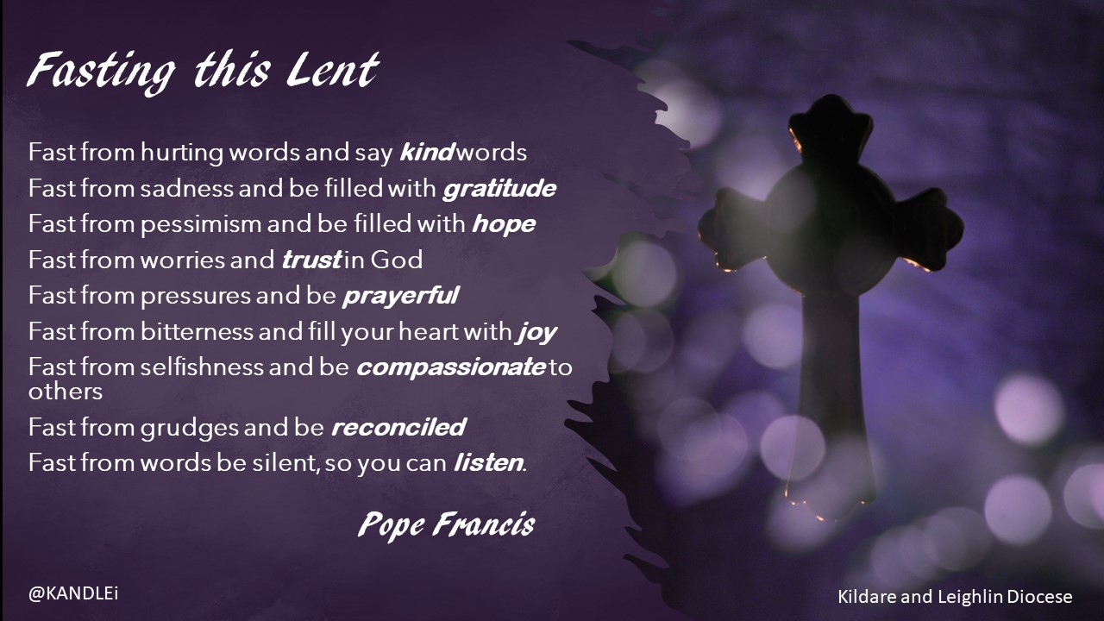

SACRIFICE
Fasting and abstinence are not sacrifices for the sake of pain or vain discomfort. Sacrifice for the sake of sacrifice is not a Christian virtue. We are asked by the Catholic Church to fast on Ash Wednesday and Good Friday, and not to eat meat on the Fridays of Lent. Feeling an empty stomach or fighting the urge to have that juicy steak or candy bar does more than just remind us that for some people an empty stomach is their daily bread. Fasting and abstinence help us to ask ourselves the question: “What sustains me and gives me life?” What nourishes me on my journey of life? We will find the answer, not in the steak or the candy bar, but at the end of these forty days of Lent—in the Resurrection of Jesus. We fast and abstain because, when we do, we are reminded of who we are—followers of the risen Christ. The Church is inviting us to look hard at our life to see how we could live with less. What can I let go of or eliminate that will bring me closer to God?

When we fast in Lent, we are also invited to think more about those people whose needs we – as individuals, as a parish or as a church – may ignore. How many people go to bed each night without having a meal that day? How many young people in the world fill their days with work simply so that the family may get by and will never have the free time or the money to enjoy TV?

As Catholics we are called to give up something for Lent. Chocolate, coffee, that extra helping of dinner, one less hour of video games or watching DVDs—whatever it is, you can make what you’re giving up for Lent a prayer as well: a prayer-in-action. Whenever you encounter the thing you are abstaining from or the time of day that you would normally enjoy it, take a moment to say a prayer in recognition of your wholeness in God even without the thing you have given up. Thank God for the freedom to be wholly yourself without this and, at the same time, acknowledge the gift of its existence in the world.

ALMSGIVING/ GIVING OF SELF
Daily life offers countless opportunities to give of yourself to others (alms), and most don’t involve dipping into your wallet. Give encouragement to the doubting, give a word of praise to the insecure, show kindness to someone who could use a friend, and offer a word of thanks to those whose service of others often goes unappreciated. Give the gift of your attention to someone who simply wants to be noticed. Tell your children stories about people whose values you admire when you gather at mealtime. Don’t be stingy with your smiles—give them freely to everyone you meet. And most important, give your love to those close to you. Hug them, hold them, and tell them what they mean to you. In this way you open your heart to God and others.

Every day we witness situations of injustice, violence, and hatred. Television and the Internet bring these into our living rooms, but we also observe and live them in our own cities and homes. The Church calls us during Lent to be especially conscious of the needs of others and to act accordingly. Giving materially to another is an act of Christian charity known as “almsgiving.” During Lent, the Church also calls us to first convert ourselves and then to transform the world for justice, so that we might serve the Kingdom which Jesus lived and preached.

