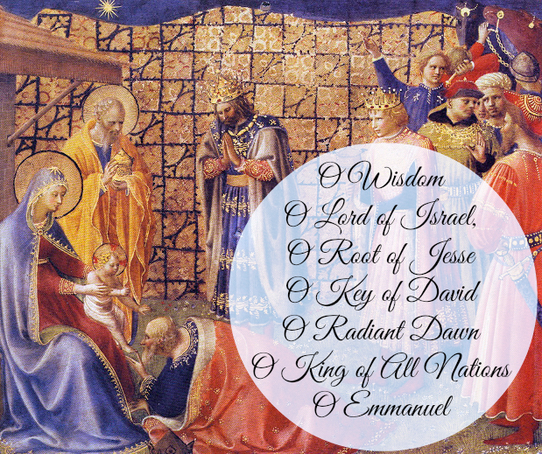

THE "O ANTIPHONS" OF ADVENT
The “O Antiphons”, is an ancient, liturgical Advent prayer from scripture, which the Roman Church has been singing since at least the eighth century. They are the antiphons that accompany the Magnificat canticle of Evening Prayer from December 17-23. They are a magnificent theology that uses ancient biblical imagery drawn from the messianic hopes of the Old Testament to proclaim the coming Christ as the fulfillment not only of Old Testament hopes, but present ones as well. Their repeated use of the imperative "Come!" embodies the longing of all for the Divine Messiah.
You can find a resource for evening prayer at iBreviary which can be found at ibreviary.com You will find evening prayer for that day when you open the website. You can also download their app.

December 17 O Sapientia
O Wisdom, O holy Word of God, you govern all creation with your strong yet tender care: Come and show your people the way to salvation.
- This antiphon invokes Christ as the divine wisdom that guides creation
- Scripture: Sirach 24: 3; Wisdom 8:1 & chapters 6 – 9; Isaiah 11: 2 – 3, 28 – 29; Isaiah 40:3 – 5; Proverbs 8:1 – 36; John 1: 1 – 5; Ecclesiasticus 24:3

December 18 O Adonai
O Leader of the House of Israel, who showed yourself to Moses in the burning bush, who gave him the holy law on Sinai Mountain. Come, stretch out your mighty hand to set us free.
- Calls upon God who revealed himself to Moses and delivered the law
- Scripture: Exodus 3: 15 – 24, Deuteronomy chapter 5; Exodus 3:2, 3:15, 6:2 – 3, 6, 12; Exodus 20; Micah 5:1, 6:4; Samuel 5:2; Isaiah 33:22, 63: 11 – 12; Matthew 2:6; Jeremiah 32:21

December 19 O Radix Jesse
O Root of Jesse’s stem, you have been raised up as a sign for all peoples; rulers stand silent in your presence; the nations bow down in worship before you. Come, let nothing keep you from coming to our aid.
- Acknowledges Christ’s lineage from Jesse, emphasizing his royal heritage.
- Scripture: Isaiah 11:1, 10; Isaiah 5:15, 52:15; Habakuk 2:3; Romans 15:12; Hebrews 10:37

December 20 O Clavis David
O Key of David, O royal Power of Israel, controlling at your will the gate of heaven: Come, break down the prison walls of death for those who dwell in darkness and the shadow of death; and lead your captive people into freedom.
- Recognizes Christ as the one who opens and closes the gates of heaven
- Scripture: Isaiah 22: 22, 42: 7; Revelation 3:7; Jeremiah 13:13, 51: 19; Matthew 4:16, 16:19; Luke 1: 7 - 9

December 21 O Oriens
O Radiant Dawn, splendor of eternal light, sun of justice: come and shine on those who dwell in darkness and in the
shadow of death.
- Refers to Christ as the light that dispels darkness and brings hope
- Scripture: Isaiah 9:1, 58:8, 60: 18 – 20; Zechariah 3:8, 6:12; Wisdom 7:26; Hebrews 1:3, Malachi 3:20, 4:2

December 22O Rex Gentium
O King of all nations and keystone of the Church: come and save us whom you formed from the dust!
- Proclaims Christ as the sovereign ruler of all peoples
- Scripture: Jeremiah 10:7; Haggai 2:8; Isaiah 2:4, 11:10,28:16; Genesis 2:7; Ephesians 2:14

December 23 O Emmanuel
O Emmanuel, our King and Giver of Law, desire of all nations, Saviour of all people,
come and set us free, Lord our God!
- O God With Us – celebrates the Incarnation of Christ. God present among us. Drawn from the famous Isaiah prophecy Isaish 7:14
- Scripture: Isaiah 7:14, 8:8, 33:22; matthew 1:23; I Timothy 4:9

O COME, O COME, EMMANUEL
O come, O come, Emmanuel,
And ransom captive Israel,
That mourns in lonely exile here
Until the Son of God appear.
Rejoice! Rejoice! Emmanuel
shall come to thee, O Israel.

O come, Thou Rod of Jesse, free
Thine own from Satan’s tyranny;
From depths of hell Thy people save,
And give them victory over the grave.
Rejoice! Rejoice! Emmanuel
shall come to thee, O Israel.

O come, Thou Day-spring, come and cheer
Our spirits by Thine advent here;
And drive away the shades of night
And pierce the clouds and bring us light!
Rejoice! Rejoice! Emmanuel
shall come to thee, O Israel.

O come, Thou Key of David, come,
And open wide our heavenly home;
Make safe the way that leads on high,
And close the path to misery.
Rejoice! Rejoice! Emmanuel
shall come to thee, O Israel.

O come, O come, Thou Lord of might,
Who to Thy tribes on Sinai’s height
In ancient times once gave the law
In cloud, and majesty, and awe.
Rejoice! Rejoice! Emmanuel
shall come to thee, O Israel.

