OUR LADY OF GUADALUPE

The Story of Our Lady of Guadalupe
On December 12 we celebrate the feast of Our Lady of Guadalupe which goes back to the 16th century. Chronicles of that period tell us the story.
A poor Indian named Cuauhtlatohuac was baptized and given the name Juan Diego. He was a 57-year-old widower and lived in a small village near Mexico City. On Saturday morning December 9, 1531, he was on his way to a nearby barrio to attend Mass in honor of Our Lady.
Juan was walking by a hill called Tepeyac when he heard beautiful music like the warbling of birds. A radiant cloud appeared, and within it stood an Indian maiden dressed like an Aztec princess. The lady spoke to him in his own language and sent him to the bishop of Mexico, a Franciscan named Juan de Zumarraga. The bishop was to build a chapel in the place where the lady appeared.
Eventually the bishop told Juan to have the lady give him a sign. About this same time Juan’s uncle became seriously ill. This led poor Juan to try to avoid the lady. Nevertheless, the lady found Juan, assured him that his uncle would recover, and provided roses for Juan to carry to the bishop in his cape or tilma.
On December 12, when Juan Diego opened his tilma in the bishop’s presence, the roses fell to the ground, and the bishop sank to his knees. On the tilma where the roses had been appeared an image of Mary exactly as she had appeared at the hill of Tepeyac.
This cloak, an abject of veneration, is preserved in the Basilica of Our Lady of Guadalupe, one of the major pilgrimage centres of North America. Devotion to Our Lady under this title has grown over the centuries and in 1946 Pius XII named her a patron of the Americas.

Prayer by Pope John Paul II
O Immaculate Virgin, Mother of the true God and Mother of the Church! You, who from this place reveal your clemency and your piety to all those who ask for your protection; hear the prayer that we address to you with filial trust, and present it to your Son, Jesus, our sole Redeemer. Mother of mercy, teacher of hidden and silent sacrifice, to you, who come to meet us sinners, we dedicate on this day all our being and all our love. Amen (catholicnewsworld.com)

A Prayer for Peace
God of power and mercy, you blessed the Americas at Tepeyac with the presence of the Virgin Mary of Guadalupe. May her prayers help all men and women to accept each other as brothers and sisters. Through your justice present in our hearts, may your peace reign in the world. We ask this through Our Lord Jesus Christ, your Son, Amen. (Catholic Online)

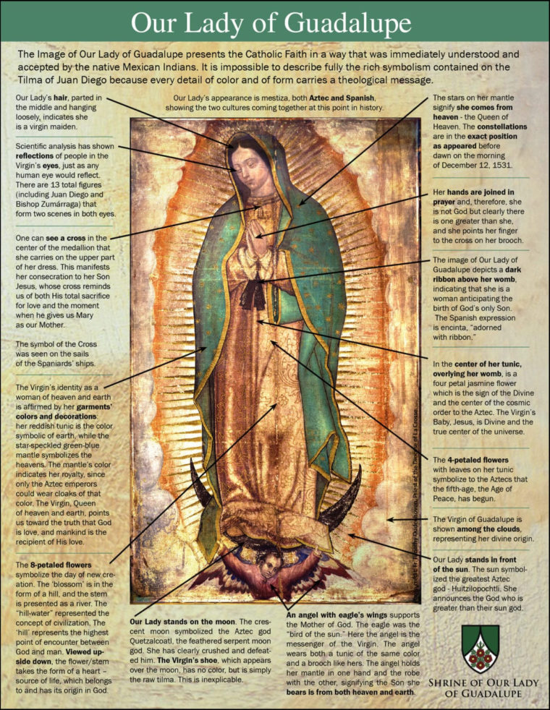

12 DECEMBER 2025 – CANADIAN CATHOLIC INDIGENOUS COUNCIL
As Catholics, we continue to reflect on the life and legacy of Pope Francis, remembering his call to be “pilgrims of hope” in this year of Jubilee. It has been a time for reconciliation, pilgrimage and “coming home”. For Christians, this “Reconciliation” is the accomplishment of Jesus Christ, whose death and resurrection reconciles humanity to God. Responding to the Lord’s call to be reconciled to one another in love, Catholic Canadians have set on a journey towards reconciliation with First Nations, Metis, and Inuit Peoples, one born out of a painful and difficult history. That history included the Indian residential schools, administered by Catholic and Christian churches alike. Accounts of prejudice, discrimination, and abuse came out of the Truth and Reconciliation Commission, which concluded ten years ago. For many people impacted by this history, healing may well require generations to realize.
We have started this journey in several ways, including the Pope’s apology and penitential pilgrimage to Canada in 2022, and a financial commitment of $30 million that promotes healing, cultural and language revitalization, and other Indigenous-led projects. These efforts complement work happening at diocesan and parish levels, as well. But much remains to be done, and there might be setbacks and disappointments as we continue the journey together with the First Peoples of this land. As Catholics, we need to share Pope Francis’ vision of Indigenous and non-Indigenous people walking together in prayerful and respectful ways towards a stronger, shared future.
As pilgrims – and communities – of hope, each of us has an important role to play in Reconciliation. This is both a Church endeavour and a personal one. We need to learn about our shared history, define lessons learned, and take steps to promote equity, opportunity, and fairness, regardless of one’s background. St. Peter, in his first letter, reminds us that, as Christians, we are called upon to give the reason for our hope. Our commitment to Reconciliation – backed by action – is what will build and sustain both real hope and good will among all peoples on Turtle Island.
“Today we pray with our ancestors who brought us where we are today. They took care of our lives and embraced Christian faith in our camps and communities. We pray that our families will continue to be strong in their faith and that the elders and the young will work closely together to create a better future.”

