**WHAT IS DIVINE MERCY SUNDAY?**

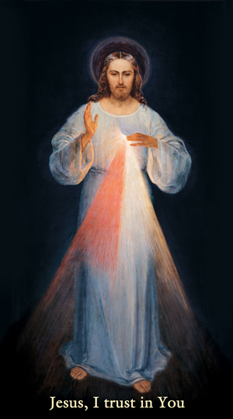

**DIVINE MERCY SUNDAY**

Liturgically the Easter Octave has always been centered on the theme of Divine Mercy and forgiveness. Divine Mercy Sunday, therefore, points us to the merciful love of God that lies behind the whole Paschal Mystery — the whole mystery of the death, burial and resurrection of Christ — made present for us in the Eucharist. In this way, it also sums up the whole Easter Octave. As Pope John Paul II pointed out in his Regina Caeli address on Divine Mercy Sunday, 1995: "the whole octave of Easter is like a single day," and the Octave Sunday is meant to be the day of "thanksgiving for the goodness God has shown to (humanity) in the whole Easter mystery."

In the Jubilee Year 2000, Pope John Paul II proclaimed that from that year forward the Second Sunday of Easter would be celebrated as Divine Mercy Sunday. This was proclaimed at the Canonization Mass of St. Faustina Kawalska, who worked throughout her life to make all aware of the merciful love of God.

St. Faustina (1905–1938) was born and raised in Poland. Following a vocation to religious life, she was accepted by the Congregation of the Sisters of Our Lady of Mercy. As a member of the Congregation, she worked as a cook, gardener, and porter. In her spiritual life, her contemplation on the Mercy of God led her to develop a childlike trust in God and deep love for her neighbor.

In her years in the convent, St. Faustina heard a call from God to make God’s mercy known to the world so that the world may more fully receive God’s healing grace. St. Faustina promoted the **Chaplet of Divine Mercy** which consists of the recitation of prayers to the Eternal Father with the use of the rosary for the sake of Christ’s sorrowful passion.

God expressed God’s will with regard to this feast in the very first revelation to St. Faustina. The most comprehensive revelation can be found in her *Diary* entry 699:

**My daughter, tell the whole world about My inconceivable mercy. I desire that the Feast of Mercy be a refuge and a shelter for all souls, and especially for poor sinners. On that day the very depths of My tender mercy are open. I pour out a whole ocean of graces upon those souls who approach the fount of My mercy. The soul that will go to Confession and receive Holy Communion shall obtain complete forgiveness of sins and punishment. On that day are opened all the divine floodgates through which graces flow. Let no soul fear to draw near to Me, even though its sins be as scarlet. My mercy is so great that no mind, be it of (human) or of angel, will be able to fathom it throughout all eternity. Everything that exists has come from the very depths of My most tender mercy. Every soul in its relation to Me will contemplate My love and mercy throughout eternity. The Feast of Mercy emerged from My very depths of tenderness. It is My desire that it be solemnly celebrated on the first Sunday after Easter. (Humanity) will not have peace until it turns to the Fount of My mercy.**

In 1931, our Lord appeared to St. Faustina in a vision. She saw Jesus clothed in a white garment with his right hand raised in blessing. His left hand was touching his garment in the area of the Heart, from where two large rays came forth, one red and the other pale. She gazed intently at the Lord in silence, her soul filled with awe, but also with great joy. Jesus said to her:

**Paint an image according to the pattern you see, with the signature: Jesus, I trust in You. I promise that the soul that will venerate this image will not perish. I also promise victory over [its] enemies already here on earth, especially at the hour of death. I Myself will defend it as My own glory (*Diary*, 47, 48). I am offering people a vessel with which they are to keep coming for graces to the fountain of mercy. That vessel is this image with the signature: Jesus, I trust in You (327). I desire that this image be venerated, first in your chapel, and [then] throughout the world (47).**  
  
When celebrating Divine Mercy Sunday, the faithful are called to reflect more personally on the graces won through the life, death, and resurrection of Jesus Christ. In this way their hearts may be more fully aware of the mercy of God for them personally and for the sake of the world.

**The Divine Mercy message** is one we can call to mind simply by remembering ABC:  
**A**- **Ask for God’s Mercy**. God wants to be constantly approached in prayer, with us repenting of our sins and asking God to pour out God’s great mercy upon us and upon the whole world.

**B- Be merciful**. God wants us to receive God’s mercy and let it flow through us to others. God wants us to extend love and forgiveness to others just as God does to us.  
**C**- **Completely trust in Jesus**. God wants us to know that all the graces of God’s mercy can only be received by our trust. The more we open the door of our hearts and lives to God with trust, the more we can receive.